**Sentry 1.6.0 移植指南（openEuler 20.03）**

|  |
| --- |
|  |

1 sentry简介

2 环境要求

3 配置编译环境

4 编译sentry

5 测试

# 1 Sentry简介

Sentry是Hadoop中的一个基于角色的细粒度授权组件。Sentry用于对存储在Hadoop集群上的数据和元数据实施基于角色的细粒度授权，可以在Hadoop集群上对通过身份认证的用户和应用程序控制数据访问权限。本文主要是描述如何将开源版本的Sentry组件适配到openEuler上。 Apache Sentry已于2016年3月成功从孵化器毕业，现在是一个顶级的Apache项目。

更多请参考官网：https://sentry.apache.org/

# 2 环境要求

**硬件要求**

|  |  |
| --- | --- |
| **项目** | **说明** |
| 服务器 | TaiShan服务器 |
| CPU | 鲲鹏920处理器 或 鲲鹏916处理器 |
| 磁盘分区 | 对磁盘分区无要求 |
| 网络 | 可访问外网 |

**软件要求**

|  |  |
| --- | --- |
| **项目** | **版本** |
| bisheng_jdk | 1.8.0_222 |
| Hadoop | 2.6.0 |
| Mysql | 5.7.27 |
| Maven | 3.2.5 |
| Hive | 1.1.0 |
| Snetry | 1.6.0 |
| Keberos |  |

**openEuler 系统**

|  |  |
| --- | --- |
| **项目** | **版本** |
| openEuler | 20.03 LTS SP1 |
| OS Kernel | 4.19.90 |

# 3 配置编译环境

## 3.1 安装OpenJDK

**步骤1** 创建java目录，下载openjdk。

cd /

mkdir bigdata

cd bigdata

wget mirrors.huaweicloud.com/kunpeng/archive/compiler/bisheng_jdk/bishen

g-jdk-8u312-linux-x64.tar.gz

**步骤2** 解压。

tar -zxvf bisheng-jdk-8u312-linux-x64.tar.gz

**步骤3** 配置环境变量。

vim /etc/profile

#最后添加如下内容

export JAVA_HOME=/bigdata/bisheng-jdk1.8.0_312

export PATH=$JAVA_HOME/bin:$PATH

source /etc/profile

检查java 是否安装成功

java -version

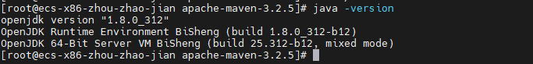

## 3.2 安装maven

**步骤1** 下载maven安装包并放到指定目录

cd /bigdata

wget <https://archive.apache.org/dist/maven/maven-3/3.2.5/binaries/>

apache-maven-3.2.5-bin.tar.gz

**步骤2** 解压

tar -zxvf apache-maven-3.2.5-bin.tar.gz

**步骤3** 配置环境变量

vim /etc/profile

在末尾添加：

export MAVEN_HOME=/bigdata/apache-maven-3.2.5

export PATH=$MAVEN_HOME/bin:$PATH

使配置生效

source /etc/profile

**步骤4** 检查maven环境变量是否正确

mvn -v

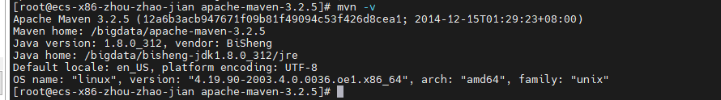

**步骤5** 修改maven的settings.xml文件中远程仓库配置

切换目录

cd /bigdata/apache-maven-3.2.5/conf/

vim settings.xml

在 mirrors 内添加如下内容：

<mirror>

<id>huaweimaven</id>

<name>huawei maven</name>

<url>https://mirrors.huaweicloud.com/repository/maven/</url>

<mirrorOf>central</mirrorOf>

</mirror>

:wq 保存并退出

## 3.3 编译Sentry

**步骤1** 下载Sentry1.6.0源码包

cd /bigdata

wget https://github.com/apache/sentry/archive/refs/tags/release-1.6.0-rc0.tar.gz

**步骤2** 解压源码包

tar -zxvf release-1.6.0-rc0.tar.gz

**步骤3** 配置鲲鹏仓库，修改pom.xml文件，保存并退出。

cd /bigdata/sentry-release-1.6.0-rc0

vim pom.xml

在repositories标签内增加鲲鹏maven仓库，鲲鹏仓库一定要放在第一位：

<repository>

<id>Kunpengmaven</id>

<name>Kunpeng maven</name>

<url>https://mirrors.huaweicloud.com/kunpeng/maven/</url>

</repository>

<repository>

<id>huaweicloud.repo</id>

<name>HuaweiCloud Repositories</name>

<url>https://mirrors.huaweicloud.com/repository/maven</url>

</repository>

<repository>

<id>wso2.repo</id>

<url>http://maven.wso2.org/nexus/content/groups/wso2-public/</url>

<name>wso2 Repositories</name>

</repository>

**步骤4** 编译Sentry

mvn clean install -DskipTests

编译结果为“sentry-dist/target/”下的apache-sentry-1.6.0-incubating-bin.tar.gz

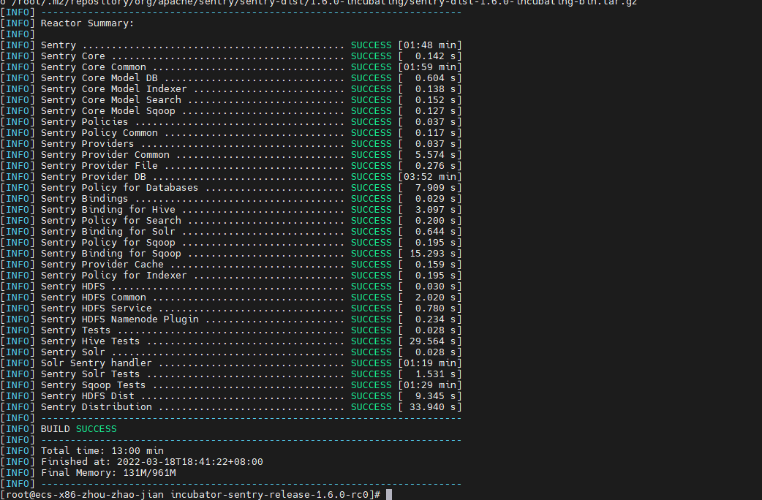

**步骤4** 复制Sentry到 /bigdata

mv apache-sentry-1.6.0-incubating-bin.tar.gz /bigdata/

解压

**步骤4** 配置sentry环境变量

vim /etc/profile

在末尾添加

export SENTRY_HOME=/bigdata/apache-sentry-1.6.0-incubating-bin

export PATH=$PATH:$SENTRY_HOME/bin

立即生效 source /etc/profile

## 3.4 安装Hadoop

**步骤1** 下载并解压Hadoop的安装包。

cd /bigdata

wget https://archive.apache.org/dist/hadoop/core/hadoop-2.6.0/hadoop-2.6.0.tar.gz

tar -zxvf hadoop-2.6.0.tar.gz

**步骤2** 配置环境变量。

vim /etc/profile

在末尾添加：

export HADOOP_HOME=/bigdata/hadoop-2.6.0

export PATH=$PATH:$HADOOP_HOME/bin:$HADOOP_HOME/sbin

:wq

保存退出即时生效：

source /etc/profile

**步骤3** 检查Hadoop环境变量

查看版本

hadoop version

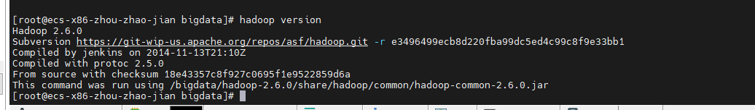

**步骤4** 关闭防火墙

systemctl disable firewalld

systemctl stop firewalld

**步骤5** 修改Hadoop的配置文件

进入配置文件主目录

cd /bigdata/hadoop-2.6.0/etc/hadoop

1. 修改hadoop-env.sh文件

vim hadoop-env.sh

找到 export JAVA_HOME= 在其后面添加：/usr/java/jdk8u222-b10 ，得到

export JAVA_HOME= /bigdata/bisheng-jdk1.8.0_312

:wq，保存并退出。

2. 修改 core-site.xml配置文件

vim core-site.xml

在<configuration>中添加如下内容

<property>

<name>hadoop.tmp.dir</name>

<value>file:/usr/local/hadoop/tmp</value>

<description>Abase for other temporary directories.</description>

</property>

<property>

<name>fs.defaultFS</name>

<value>hdfs://localhost:9000</value>

</property>

：wq ，保存并退出

3. 修改hdfs-site.xml配置文件，在<configuration>标签内添加如下内容：

<property>

<name>dfs.replication</name>

<value>1</value>

</property>

<property>

<name>dfs.namenode.name.dir</name>

<value>file:/usr/local/hadoop/tmp/dfs/name</value>

</property>

<property>

<name>dfs.datanode.data.dir</name>

<value>file:/usr/local/hadoop/tmp/dfs/data</value>

</property>

4.添加mapred-site.xml文件

vim yarn-site.xml，添加如下内容

<?xml version="1.0"?>

<?xml-stylesheet type="text/xsl" href="configuration.xsl"?>

<!--

Licensed under the Apache License, Version 2.0 (the "License");

you may not use this file except in compliance with the License.

You may obtain a copy of the License at

http://www.apache.org/licenses/LICENSE-2.0

Unless required by applicable law or agreed to in writing, software

distributed under the License is distributed on an "AS IS" BASIS,

WITHOUT WARRANTIES OR CONDITIONS OF ANY KIND, either express or implied.See the License for the specific language governing permissions and limitations under the License. See accompanying LICENSE file.

-->

<!-- Put site-specific property overrides in this file. -->

<configuration>

<property>

<name>mapreduce.framework.name</name>

<value>yarn</value>

</property>

</configuration>

：wq ，保存并退出。

5. 修改yarn-site.xml，

vim yarn-site.xml，添加如下配置

<configuration>

<!-- Site specific YARN configuration properties -->

<property>

<name>yarn.nodemanager.aux-services</name>

<value>mapreduce_shuffle</value>

</property>

</configuration>

:wq保存并退出

**步骤6** 格式化节点

hdfs namenode -format

**步骤7** 设置 ssh免密登陆

cd /bigdata

ssh-keygen -t rsa （直接回车执行）

cd ~/.ssh

chmod 600 authorized_keys

cat id_rsa.pub >> authorized_keys

**步骤8** 启动Hadoop

start-all.sh

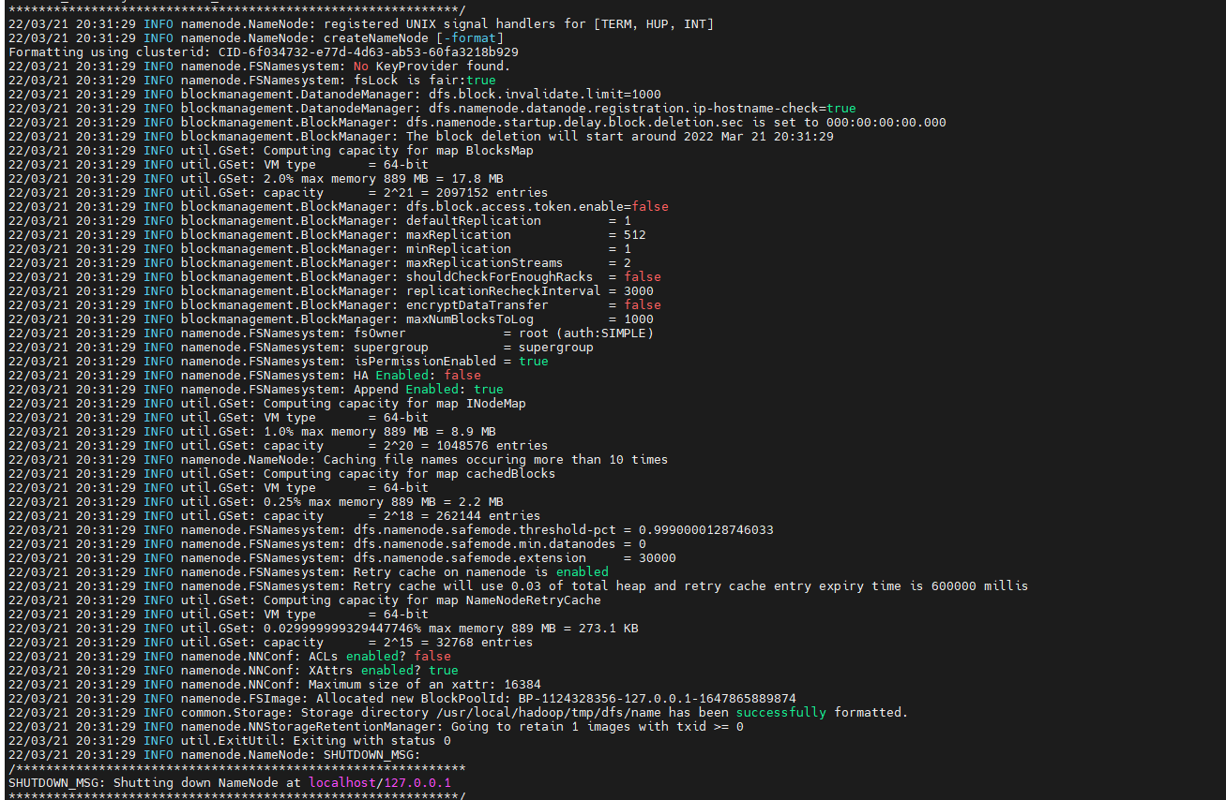

**步骤9** 验证Hadoop

Jps

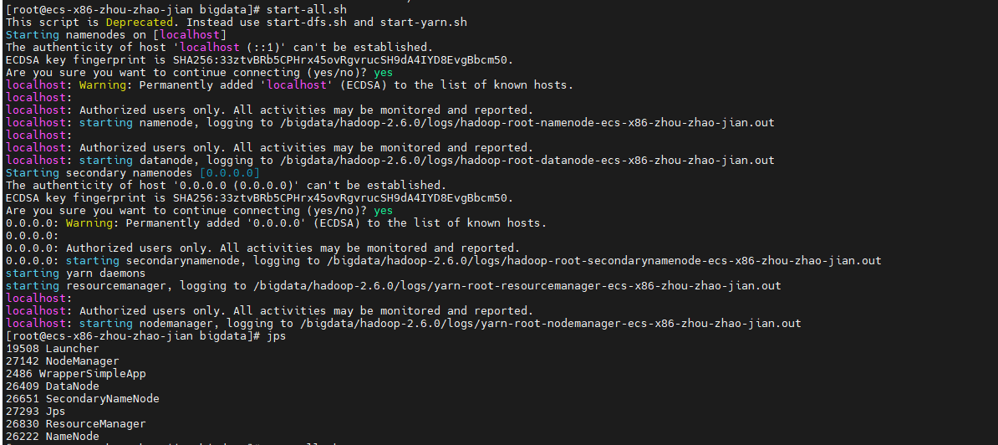

## 3.5 安装MySQL

**步骤1** 下载MySql依赖包和源码

cd /bigdata/

安装依赖库

yum install -y libaio*

wget https://downloads.mysql.com/archives/get/p/23/file/mysql-5.7.12-linux-glibc2.5-x86_64.tar.gz

**步骤2** 解压MySql并复制

tar -xvf mysql-5.7.12-linux-glibc2.5-x86_64.tar.gz -C /usr/local/

**步骤3** 配置MySql

mv /usr/local/ mysql-5.7.12-linux-glibc2.5-x86_64 /usr/local/mysql

mkdir -p /usr/local/mysql/logs

mkdir /usr/local/mysql/data

touch /usr/local/mysql/logs/mysqld.log

groupadd -r mysql && useradd -r -g mysql -s /sbin/nologin -M mysql

chown -R mysql:mysql /usr/local/mysql

cp -rf /usr/local/mysql/support-files/mysql.server /etc/init.d/mysqld

chmod +x /etc/init.d/mysqld

systemctl enable mysqld

**步骤4** 配置环境变量

vim /etc/profile

在末尾添加：

export MYSQL_HOME=/usr/local/mysql

export PATH=$PATH:$MYSQL_HOME/bin

立即生效：

source /etc/profile

**步骤5** 初始化mysql

cd /usr/local/mysql/bin

./mysqld --initialize-insecure --user=mysql --basedir=/usr/local/mysql --datadir=/usr/local/mysql/data

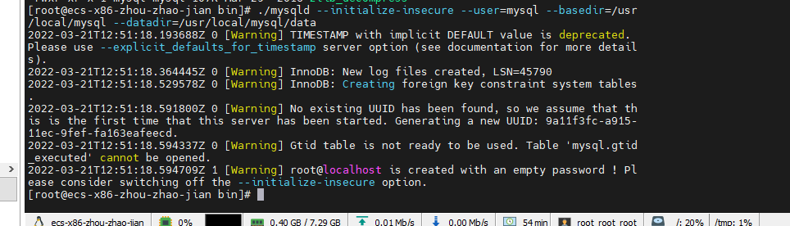

启动mysql

systemctl start mysqld

查看状态

systemctl status mysqld

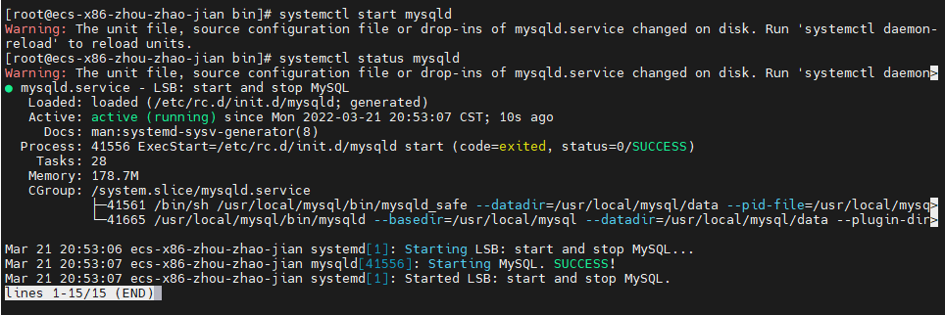

**步骤6** 修改root用户密码

mysql -u root

初始密码为空，直接回车登录

输入如下命令修改密码

use mysql;

update user set authentication_string=password('123456') where user = 'root' and host = 'localhost';

GRANT ALL PRIVILEGES ON *.* TO 'root'@'%' IDENTIFIED BY '123456';

# 刷新权限

flush privileges;

退出

exit;

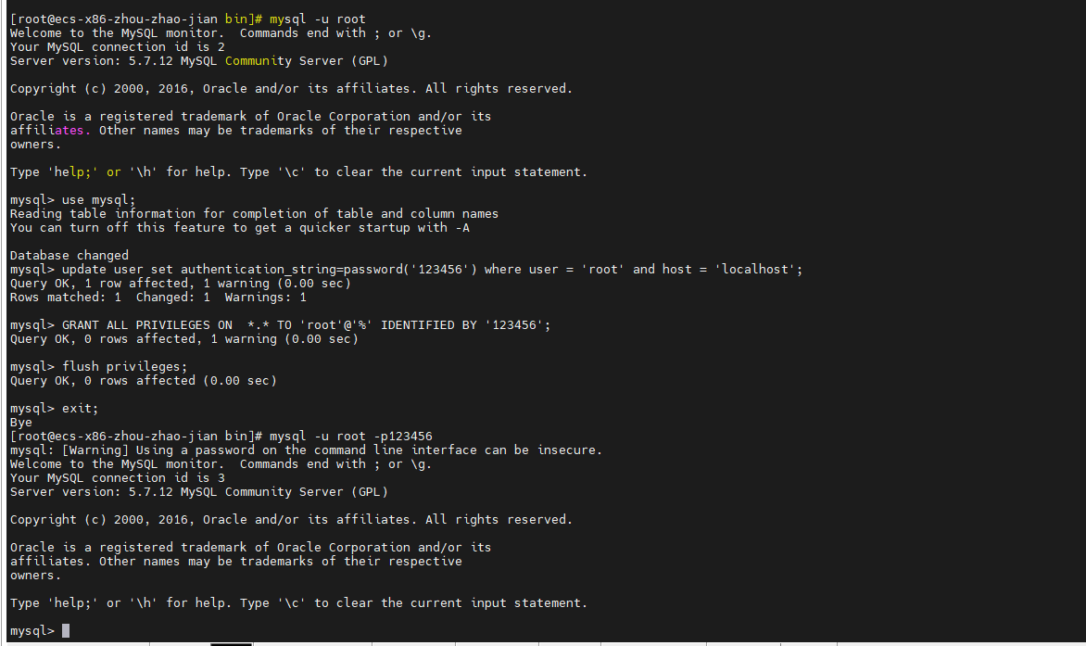

## 3.5 安装Hive

**步骤1** 下载并解压Hive的安装包。

cd /bigdata

wget https://archive.apache.org/dist/hive/hive-1.1.0/apache-hive-1.1.0-bin.tar.gz

tar -zxvf apache-hive-1.1.0-bin.tar.gz

**步骤2** 配置Hive环境变量

vim /etc/profile

在末尾添加如下内容

export HIVE_HOME=/bigdata/apache-hive-1.1.0-bin

export PATH=$PATH:$HIVE_HOME/bin

:wq ，保存并退出，立即生效

vim

**步骤3** 修改Hive配置文件

cd /bigdata/apache-hive-1.1.0-bin/conf

vim hive-site.xml

添加如下内容：

<configuration>

<property>

<name>javax.jdo.option.ConnectionURL</name>

<value>jdbc:mysql://localhost:3306/hive?createDatabaseIfNotExist=true&amp;useSSL=false</value>

</property>

<property>

<name>javax.jdo.option.ConnectionDriverName</name>

<value>com.mysql.jdbc.Driver</value>

</property>

<property>

<name>javax.jdo.option.ConnectionUserName</name>

<value>root</value>

</property>

<property>

<name>javax.jdo.option.ConnectionPassword</name>

<value>123456</value>

</property>

<property>

<name>hive.server2.thrift.bind.host</name>

<value>localhost</value>

</property>

<property>

<name>hive.server2.thrift.port</name>

<value>10000</value>

</property>

</configuration>

**步骤4** 下载JDBC连接包

cd /bigdata/apache-hive-1.1.0-bin/lib

wget https://repo1.maven.org/maven2/mysql/mysql-connector-java/5.1.47/mysql-connector-java-5.1.47.jar

替换hadoop中jline的jar包

cd /bigdata/apache-hive-1.1.0-bin

cp lib/jline-2.12.jar ../hadoop-2.6.0/share/hadoop/yarn/lib/

rm ${HADOOP_HOME}/share/hadoop/yarn/lib/jline-0.9.94.jar

cp ${SENTRY_HOME}/lib/jline-2.12.jar　${HADOOP_HOME}/share/hadoop/yarn/lib

**步骤５** 初始化Hive原数据库

cd /bigdata/apache-hive-1.1.0-bin/

schematool -dbType mysql -initSchema

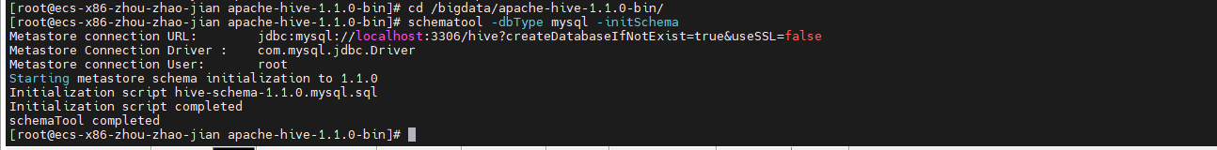

初始化成功！

# hive 测试

# start-all.sh

# ４整合Sentry

**步骤1** 将编译好的Sentry复制到工作路径并解压

cd /bigdata/sentry-release-1.6.0-rc0/sentry-dist/target

cp apache-sentry-1.6.0-incubating-bin.tar.gz /bigdata

**步骤2** 解压sentry。

cd /bigdata

tar -zxvf apache-sentry-1.6.0-incubating-bin.tar.gz

**步骤3** 下载mysql驱动

cd /bigdata/apache-sentry-1.6.0-incubating-bin/lib

wget https://repo1.maven.org/maven2/mysql/mysql-connector- java/5.1.47/mysql-connector-java-5.1.47.jar

**步骤4** 修改配置文件

vim /bigdata/apache-sentry-1.6.0-incubating-bin/conf/sentry-site.xml

添加如下内容

<?xml version="1.0"?>

<?xml-stylesheet type="text/xsl" href="configuration.xsl"?>

<!--

Licensed to the Apache Software Foundation (ASF) under one or more

contributor license agreements. See the NOTICE file distributed with

this work for additional information regarding copyright ownership.

The ASF licenses this file to You under the Apache License, Version 2.0

(the "License"); you may not use this file except in compliance with

the License. You may obtain a copy of the License at

http://www.apache.org/licenses/LICENSE-2.0

Unless required by applicable law or agreed to in writing, software

distributed under the License is distributed on an "AS IS" BASIS,

WITHOUT WARRANTIES OR CONDITIONS OF ANY KIND, either express or implied.

See the License for the specific language governing permissions and

limitations under the License.

-->

<!-- WARNING!!! This file is provided for documentation purposes ONLY! -->

<!-- WARNING!!! You should copy to sentry-site.xml and make modification instead. -->

<configuration>

<property>

<name>sentry.service.allow.connect</name>

<value>hive,admin</value>

<description>comma separated list of users - List of users that are allowed to connect to the service (eg Hive, Impala) </description>

</property>

<property>

<name>sentry.store.jdbc.url</name>

<value>jdbc:mysql://localhost:3306/sentry?createDatabaseIfNotExist=true&amp;useSSL=false</value>

<description>JDBC connection URL for the backed DB</description>

</property>

<property>

<name>sentry.store.jdbc.user</name>

<value>root</value>

<description>Userid for connecting to backend db </description>

</property>

<property>

<name>sentry.store.jdbc.password</name>

<value>123456</value>

<description>Sentry password for backend JDBC user </description>

</property>

<property>

<name>sentry.service.server.rpcport</name>

<value>8038</value>

<description> TCP port number for service</description>

</property>

<property>

<name>sentry.service.server.rpcaddress</name>

<value>0.0.0.0</value>

<description> TCP interface for service to bind to</description>

</property>

<property>

<name>sentry.store.jdbc.driver</name>

<value>com.mysql.jdbc.Driver</value>

<description>Backend JDBC driver - org.apache.derby.jdbc.EmbeddedDriver (only when dbtype = derby) JDBC Driver class for the backed DB</description>

</property>

<property>

<name>sentry.service.admin.group</name>

<value>admin</value>

<description>Comma separates list of groups. List of groups allowed to make policy updates</description>

</property>

<property>

<name>sentry.store.group.mapping</name>

<value>org.apache.sentry.provider.common.HadoopGroupMappingService</value>

<description>

Group mapping class for Sentry service. org.apache.sentry.provider.file.LocalGroupMapping service can be used for local group mapping. </description>

</property>

<property>

<name>sentry.service.security.mode</name>

<value>none</value>

<description>Options: kerberos, none. Authentication mode for Sentry service. Currently supports Kerberos and trusted mode </description>

</property>

<property>

<name>sentry.service.server.principal</name>

<value> </value>

</property>

<property>

<name>sentry.service.server.keytab</name>

<value> </value>

</property>

<property>

<name>sentry.service.reporting</name>

<value>JMX</value>

</property>

<property>

<name>sentry.service.server.rpc-address</name>

<value>localhost</value>

</property>

<property>

<name>sentry.service.server.rpc-port</name>

<value>8038</value>

</property>

<property>

<name>sentry.hive.server</name>

<value>server1</value>

</property>

<property>

<name>sentry.service.web.enable</name>

<value>true</value>

</property>

<property>

<name>sentry.service.web.port</name>

<value>51000</value>

</property>

<property>

<name>sentry.service.web.authentication.type</name>

<value>NONE</value>

</property>

</configuration>

**步骤5** 配置Sentry环境变量

vim /etc/profile

在末尾添加

export SENTRY_HOME=/bigdata/apache-sentry-1.6.0-incubating-bin

export PATH=$PATH:$SENTRY_HOME/bin

立即生效

source /etc/profile

**步骤6** 在mysql中创建sentry数据库

cd /bigdata

mysql -uroot -p123456

create database sentry;

CREATE USER sentry IDENTIFIED BY 'sentry';

GRANT all ON sentry.* TO sentry@'%' IDENTIFIED BY 'sentry';

flush privileges;

exit;

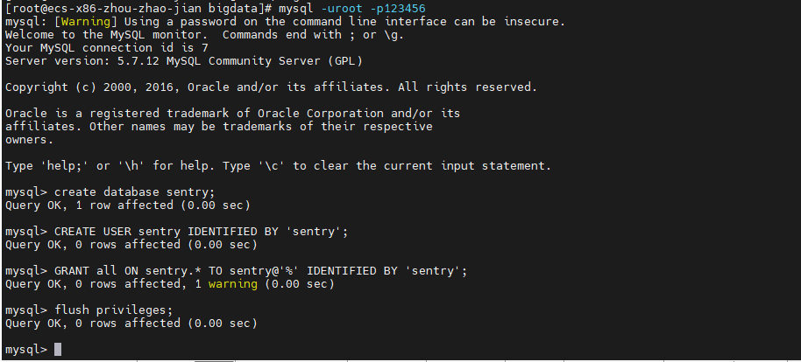

cd /bigdata/

chmod -R 755 /bigdata/

**步骤7** 初始化sentry数据库

cd /bigdata

sentry --command schema-tool --conffile ${SENTRY_HOME}/conf/sentry-site.xml --dbType mysql --initSchema

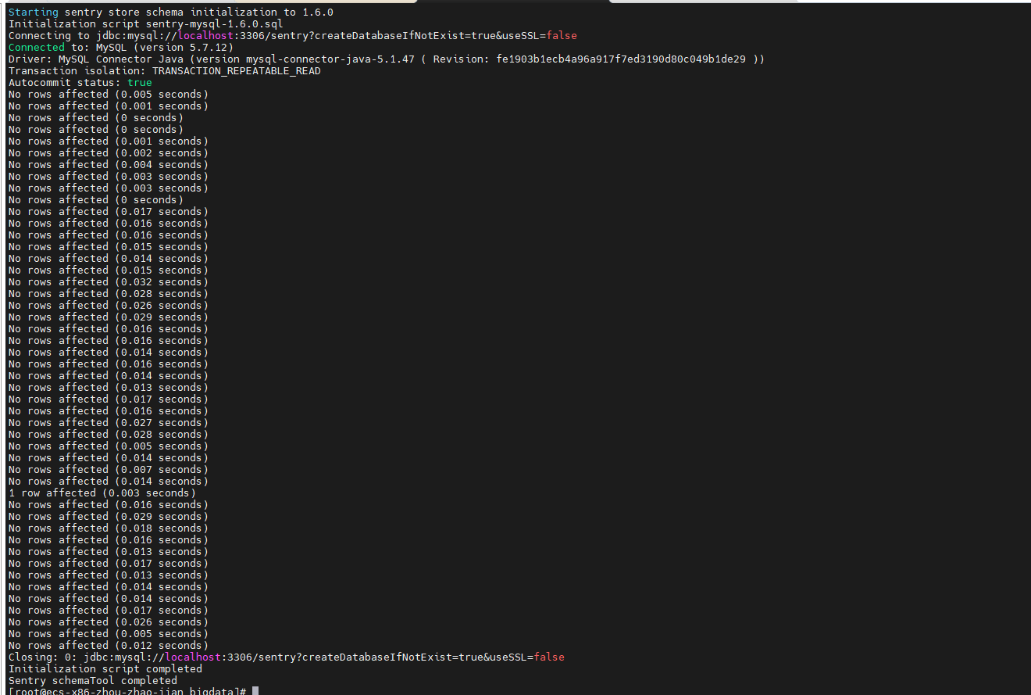

创建日志目录

mkdir logs

**步骤8** 启动sentry服务

nohup sentry --command service --conffile ${SENTRY_HOME}/conf/sentry-site.xml >> /bigdata/logs/sentry.log 2>&1 &

**步骤8** 修改hive-site.xml配置文件

cd /bigdata

vim /bigdata/apache-hive-1.1.0-bin/conf/hive-site.xml

修改为如下内容：

<configuration>

<property>

<name>javax.jdo.option.ConnectionURL</name>

<value>jdbc:mysql://localhost:3306/hive?createDatabaseIfNotExist=true&amp;useSSL=false</value>

</property>

<property>

<name>javax.jdo.option.ConnectionDriverName</name>

<value>com.mysql.jdbc.Driver</value>

</property>

<property>

<name>javax.jdo.option.ConnectionUserName</name>

<value>root</value>

</property>

<property>

<name>javax.jdo.option.ConnectionPassword</name>

<value>123456</value>

</property>

<property>

<name>hive.server2.thrift.bind.host</name>

<value>localhost</value>

</property>

<property>

<name>hive.server2.thrift.port</name>

<value>10000</value>

</property>

<property>

<name>hive.sentry.conf.url</name>

<value>file:///bigdata/apache-hive-1.1.0-bin/conf/sentry-site.xml</value>

</property>

<property>

<name>hive.stats.collect.scancols</name>

<value>true</value>

</property>

<property>

<name>hive.metastore.pre.event.listeners</name>

<value>org.apache.sentry.binding.metastore.MetastoreAuthzBinding</value>

</property>

<property>

<name>hive.metastore.event.listeners</name>

<value>org.apache.sentry.binding.metastore.SentryMetastorePostEventListener</value>

</property>

<property>

<name>hive.server2.session.hook</name>

<value>org.apache.sentry.binding.hive.HiveAuthzBindingSessionHook</value>

</property>

<property>

<name>hive.security.authorization.task.factory</name>

<value>org.apache.sentry.binding.hive.SentryHiveAuthorizationTaskFactoryImpl</value>

</property>

</configuration>

**步骤9** 修改sentry-site.xml配置文件

vim /bigdata/apache-hive-1.1.0-bin/conf/sentry-site.xml

添加如下内容：

<configuration>

<property>

<name>sentry.service.client.server.rpc-address</name>

<value>localhost</value>

</property>

<property>

<name>sentry.service.client.server.rpc-port</name>

<value>8038</value>

</property>

<property>

<name>sentry.service.client.server.rpc-connection-timeout</name>

<value>200000</value>

</property>

<!--配置认证-->

<property>

<name>sentry.service.security.mode</name>

<value>none</value>

</property>

<property>

<name>sentry.service.server.principal</name>

<value></value>

</property>

<property>

<name>sentry.service.server.keytab</name>

<value></value>

</property>

<property>

<name>sentry.provider</name> <value>org.apache.sentry.provider.file.HadoopGroupResourceAuthorizationProvider</value>

</property>

<property>

<name>sentry.hive.provider.backend</name> <value>org.apache.sentry.provider.db.SimpleDBProviderBackend</value>

</property>

<property>

<name>sentry.metastore.service.users</name>

<value>hive</value>

<!--queries made by hive user (beeline) skip meta store check-->

</property>

<property>

<name>sentry.hive.server</name>

<value>server1</value>

</property>

<property>

<name>sentry.hive.testing.mode</name>

<value>true</value>

</property>

</configuration>

**步骤10** 复制相关的jar包

cp ${SENTRY_HOME}/lib/sentry*.jar ${HIVE_HOME}/lib

cp ${SENTRY_HOME}/lib/shiro-*.jar ${HIVE_HOME}/lib

**步骤11** 创建warehouse并修改权限

启动hadoop之后

hdfs dfs -mkdir -p /user/hive/warehouse

hadoop fs -chown -R hive:hive /user/hive/warehouse

hadoop fs -chmod -R 777 /user/hive/warehouse

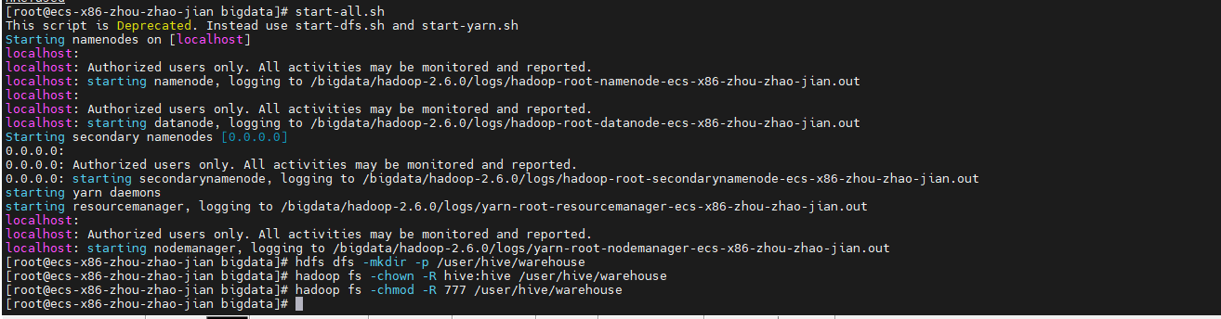

**步骤12** 关闭sentry并重启

kill -9 `ps -aux|grep sentry|grep -v "grep"|awk '{print $2}'`

nohup sentry --command service --conffile ${SENTRY_HOME}/conf/sentry-site.xml >> /bigdata/logs/sentry.log 2>&1 &

启动hive服务

nohup hive --service metastore >> /bigdata/logs/hive-metastore.log 2>&1 &

nohup hive --service hiveserver2 >> /bigdata/logs/hive-server2.log 2>&1 &

# 5 测试sentry

**步骤1** 创建测试数据

cd /bigdata

mkdir data

vim /bigdata/data/events.csv

# 添加如下测试数据

10.1.2.3,US,android,createNote

10.200.88.99,FR,windows,updateNote

10.1.2.3,US,android,updateNote

10.200.88.77,FR,ios,createNote

10.1.4.5,US,windows,updateTag

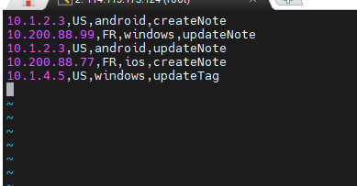

# 修改文件权限

chmod -R 755 /bigdata/

**步骤2** 添加用户

adduser hive

切换用户

su - hive

**步骤3** 初始化数据

hive

create database sensitive;

# 创建表

create table sensitive.events (ip STRING, country STRING, client STRING, action STRING) ROW FORMAT DELIMITED FIELDS TERMINATED BY ',';

# 加载本地测试数据

load data local inpath '/bigdata/data/events.csv' overwrite into table sensitive.events;

创建数据库和表

create database filtered;

create view filtered.events as select country, client, action from sensitive.events;

create view filtered.events_usonly as select * from filtered.events where country = 'US';

退出

exit;

logout

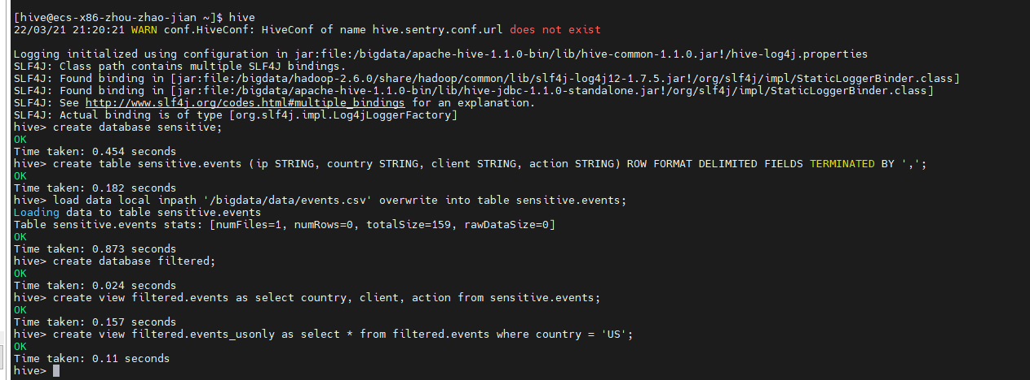

**步骤4** 验证sentry权限控制-添加角色组和赋予不同权限

创建admin 用户

adduser admin

切换用户

su - admin

使用beeline 连接工具

beeline -u "jdbc:hive2://localhost:10000/" -n admin -p admin -d org.apache.hive.jdbc.HiveDriver

create role admin_role;

GRANT ALL ON SERVER server1 TO ROLE admin_role;

GRANT ROLE admin_role TO GROUP admin;

create role test_role;

GRANT ALL ON DATABASE filtered TO ROLE test_role;

use sensitive;

GRANT SELECT(ip) on TABLE sensitive.events TO ROLE test_role;

GRANT ROLE test_role TO GROUP test;

# 退出

!exit

logout

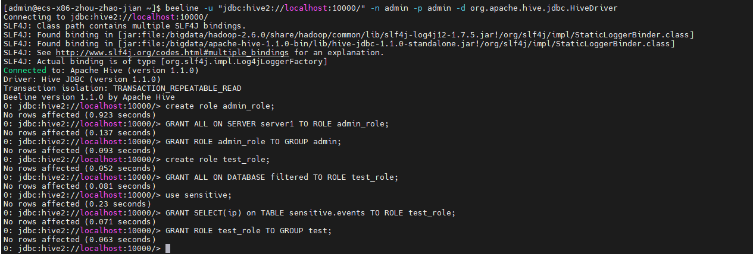

**步骤5** 验证admin_role权限

beeline -u "jdbc:hive2://localhost:10000/" -n admin -p admin -d org.apache.hive.jdbc.HiveDriver

# admin 用户 查看角色、权限、数据库等信息

show roles;

show grant role admin_role;

show grant role test_role;

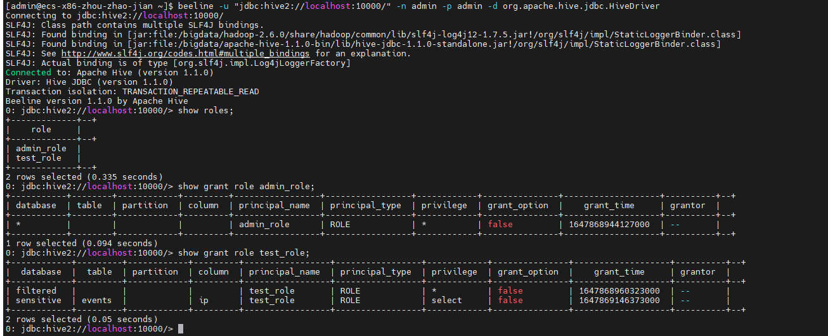

show databases;

# 测试查询操作

select * from filtered.events;

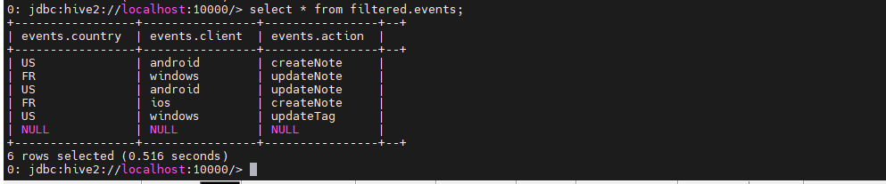

select * from sensitive.events;

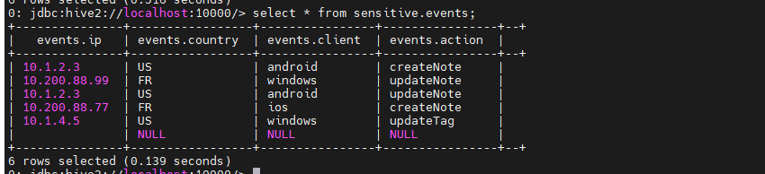

!exit

logout

**步骤6** 退出hive命令行之后，验证test用户权限

# 添加test 用户

useradd test

su - test

beeline -u "jdbc:hive2://localhost:10000/" -n test -p test -d org.apache.hive.jdbc.HiveDriver

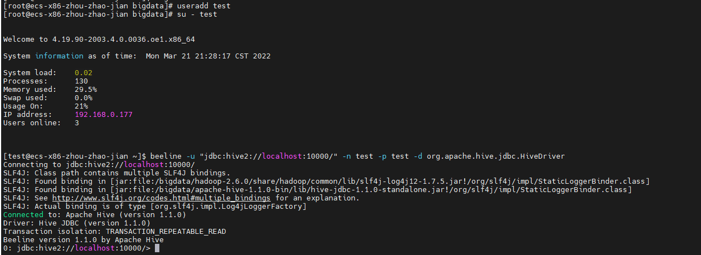

# test用户不是管理员，是不能查看所有角色的

show roles;

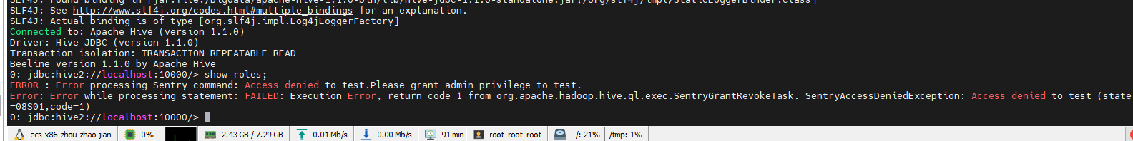

# ERROR : Error processing Sentry command: Access denied to test.Please grant admin privilege to test.

# Error: Error while processing statement: FAILED: Execution Error, return code 1 from org.apache.hadoop.hive.ql.exec.SentryGrantRevokeTask.

# SentryAccessDeniedException: Access denied to test (state=08S01,code=1)

# test用户可以列出所有数据库

show databases;

# test用户拥有filtered库

use filtered;

select * from events;

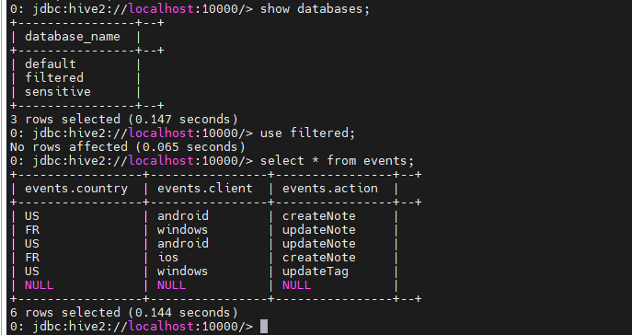

# test用户只能查看sensitive库中events表中的ip字段，其他的都都无法查看

# 可以正常查看 ip字段

use sensitive;

select ip from events;

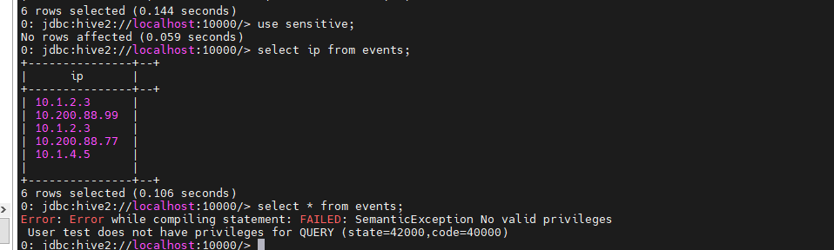

退出

!exit

logout

# 6 安装Kerberos

**步骤1** yum install -y krb5-libs krb5-server krb5-workstation krb5-devel

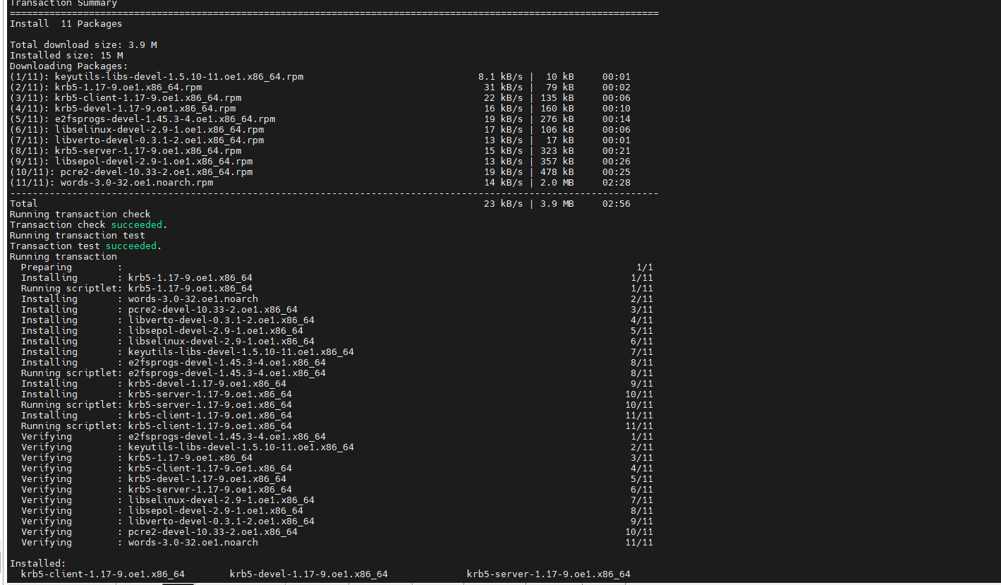

**步骤2**下载这个网址的zip文件 <https://www.oracle.com/java/technologies/javase-jce8-downloads.html>

解压得到两个jar包，上传到服务器～/

mv local_policy.jar $JAVA_HOME/jre/lib/security

mv US_export_policy.jar $JAVA_HOME/jre/lib/security

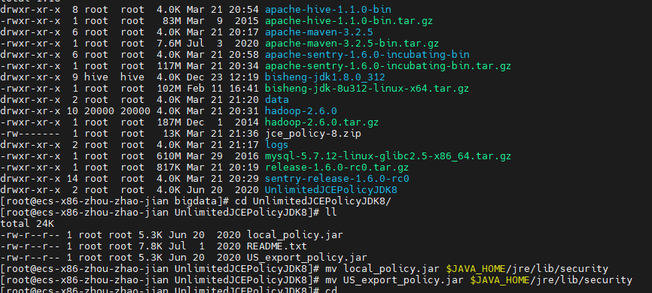

**步骤3**修改配置文件

vim /etc/krb5.conf

[logging]

default = FILE:/var/log/krb5libs.log

kdc = FILE:/var/log/krb5kdc.log

admin_server = FILE:/var/log/kadmind.log

[libdefaults]

default_realm = EXAMPLE.COM

dns_lookup_kdc = false

dns_lookup_realm = false

ticket_lifetime = 86400

renew_lifetime = 604800

forwardable = true

default_tgs_enctypes = rc4-hmac des3-cbc-sha1 arcfour-hmac aes256-cts des-cbc-md5 des-cbc-crc

default_tkt_enctypes = rc4-hmac des3-cbc-sha1 arcfour-hmac aes256-cts des-cbc-md5 des-cbc-crc

permitted_enctypes = rc4-hmac des3-cbc-sha1 arcfour-hmac aes256-cts des-cbc-md5 des-cbc-crc udp_preference_limit = 1

kdc_timeout = 3000

[realms]

EXAMPLE.COM = {

kdc = localhost

admin_server = localhost

}

vim /var/kerberos/krb5kdc/kdc.conf

[kdcdefaults]

kdc_ports = 88

kdc_tcp_ports = 88

[realms]

EXAMPLE.COM = {

#master_key_type = aes256-cts

acl_file = /var/kerberos/krb5kdc/kadm5.acl

dict_file = /usr/share/dict/words

admin_keytab = /var/kerberos/krb5kdc/kadm5.keytab

supported_enctypes = aes256-cts:normal aes128-cts:normal des3-hmac-sha1:normal arcfour-hmac:normal camellia256-cts:normal camellia128-cts:normal des-hmac-sha1:normal des-cbc-md5:normal des-cbc-crc:normal

}

**步骤4**生成规则

kdb5_util create -r EXAMPLE.COM –s

输入密码：admin, 两次

**步骤5**创建admin

kadmin.local -q "addprinc admin/admin"

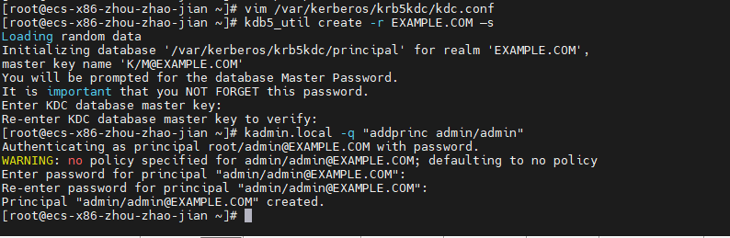

**步骤6** 开机自启动

chkconfig krb5kdc on

chkconfig kadmin on

service krb5kdc start

service kadmin start

service krb5kdc status

安装并启动成功

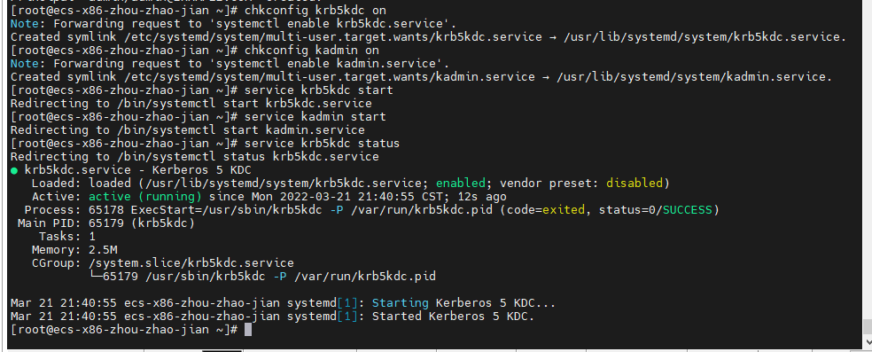

**步骤7 Hadoop hive**

1、先停止hadoop和hive

stop-all.sh

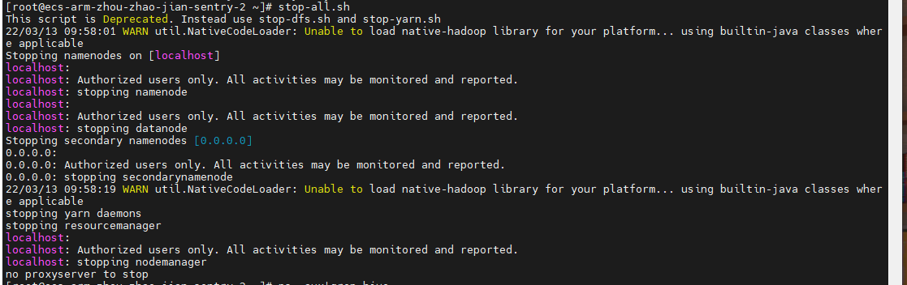

查看hive进程

ps -aux|grep hive

kill -9 hive进程号

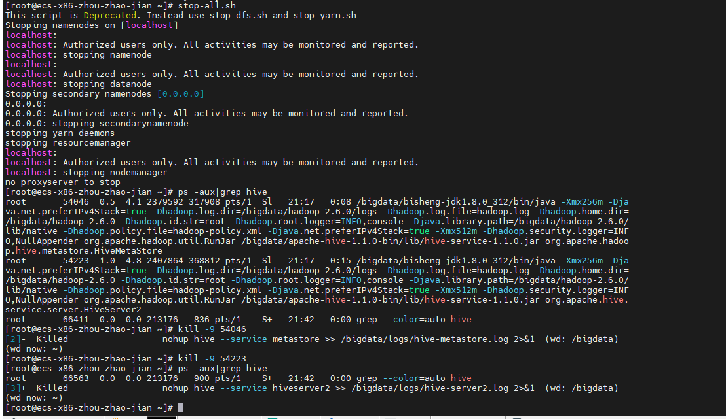

**步骤8** 分别创建hive，Hadoop配置文件

mkdir -p /etc/hadoop/conf

修改权限

chmod -R 755 /etc/hadoop/

mkdir -p /etc/hive/conf

chmod -R 755 /etc/hive/

chmod -R 777 /tmp

**步骤9**创建服务端的规则

kadmin.local -q "addprinc -randkey hdfs/localhost@EXAMPLE.COM"

kadmin.local -q "addprinc -randkey mapred/localhost@EXAMPLE.COM"

kadmin.local -q "addprinc -randkey [yarn/localhost@EXAMPLE.COM](mailto:yarn/localhost@EXAMPLE.COM)"

kadmin.local -q "addprinc -randkey [HTTP/localhost@EXAMPLE.COM](mailto:HTTP/localhost@EXAMPLE.COM)"

kadmin.local -q "addprinc -randkey hive/localhost@EXAMPLE.COM"

kadmin.local -q "addprinc -randkey admin/localhost@EXAMPLE.COM"

kadmin.local -q "addprinc -randkey test/localhost@EXAMPLE.COM"

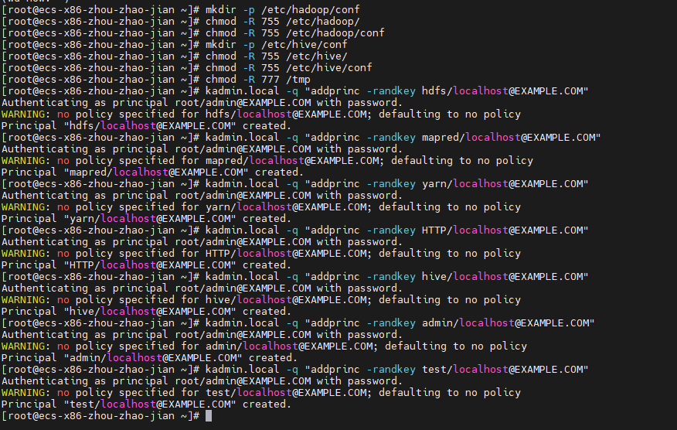

**步骤10** 生成对应的keytab

kadmin.local -q "xst -norandkey -k /etc/hadoop/conf/hdfs.keytab hdfs/localhost@EXAMPLE.COM [HTTP/localhost@EXAMPLE.COM](mailto:HTTP/localhost@EXAMPLE.COM)"

kadmin.local -q "xst -norandkey -k /etc/hadoop/conf/mapred.keytab mapred/localhost@EXAMPLE.COM [HTTP/localhost@EXAMPLE.COM](mailto:HTTP/localhost@EXAMPLE.COM)"

kadmin.local -q "xst -norandkey -k /etc/hadoop/conf/yarn.keytab yarn/localhost@EXAMPLE.COM HTTP/localhost@EXAMPLE.COM "

kadmin.local -q "xst -norandkey -k /etc/hive/conf/hive.keytab hive/localhost@EXAMPLE.COM "

kadmin.local -q "xst -norandkey -k /etc/hive/conf/admin.keytab admin/localhost@EXAMPLE.COM "

kadmin.local -q "xst -norandkey -k /etc/hive/conf/test.keytab test/localhost@EXAMPLE.COM "

**步骤11** 添加用户组：

groupadd hadoop;useradd hdfs -g hadoop -p hdfs;useradd hive -g hadoop -p hive;useradd yarn -g hadoop -p yarn;useradd mapred -g hadoop -p mapred

**步骤12** 生成用户Kerberos票据，票据有时间限制

chown hdfs:hadoop /etc/hadoop/conf/hdfs.keytab

chown mapred:hadoop /etc/hadoop/conf/mapred.keytab

chown yarn:hadoop /etc/hadoop/conf/yarn.keytab

chown hive:hadoop /etc/hive/conf/hive.keytab

chown admin:hadoop /etc/hive/conf/admin.keytab

chown test:hadoop /etc/hive/conf/test.keytab

6、修改权限

chmod 400 /etc/hadoop/conf/*.keytab

chmod 400 /etc/hive/conf/*.keytab

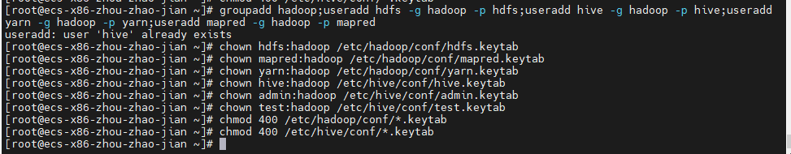

**步骤13** 创建HTTPS证书

mkdir /etc/hadoop/https

cd /etc/hadoop/https/

openssl req -new -x509 -keyout bd_ca_key -out bd_ca_cert -days 9999 -subj '/C=CN/ST=beijing/L=beijing/O=test/OU=test/CN=test'

密码 全部 123456

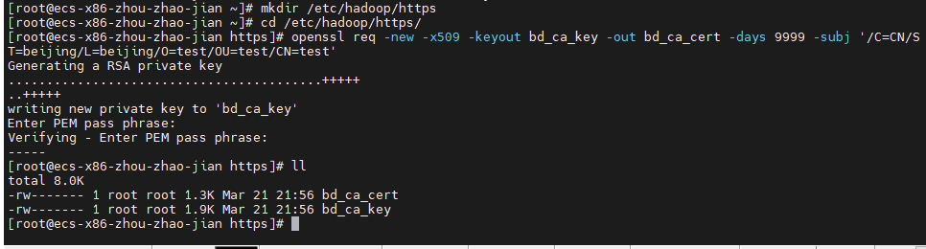

**步骤14** 保存相关文件

keytool -keystore keystore -alias localhost -validity 9999 -genkey -keyalg RSA -keysize 2048 -dname "CN=test,OU=test,O=test,L=beijing,ST=beijing,C=CN"

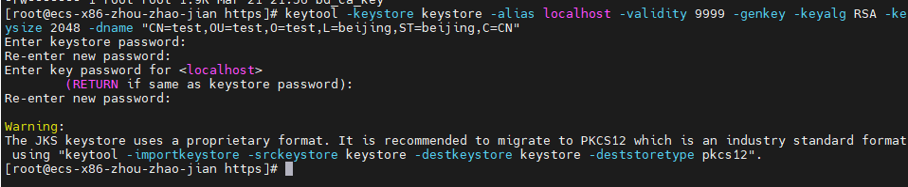

keytool -keystore truststore -alias CARoot -import -file bd_ca_cert

密码123456 ，并确定 y

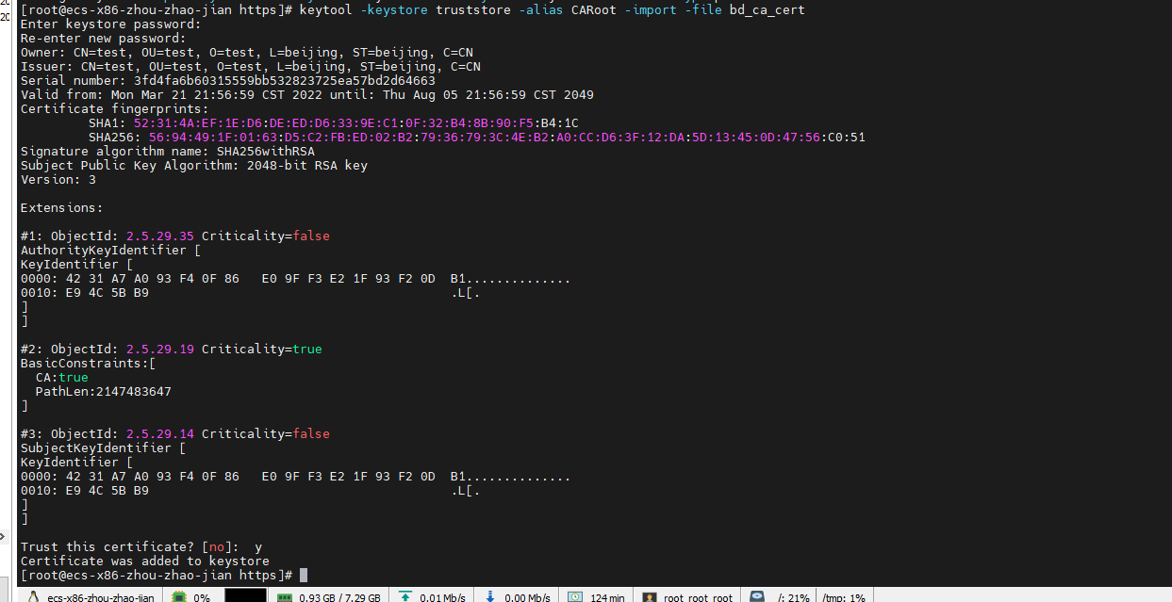

keytool -certreq -alias localhost -keystore keystore -file cert

密码 123456



openssl x509 -req -CA bd_ca_cert -CAkey bd_ca_key -in cert -out cert_signed -days 9999 -CAcreateserial -passin pass:123456



keytool -keystore keystore -alias CARoot -import -file bd_ca_cert

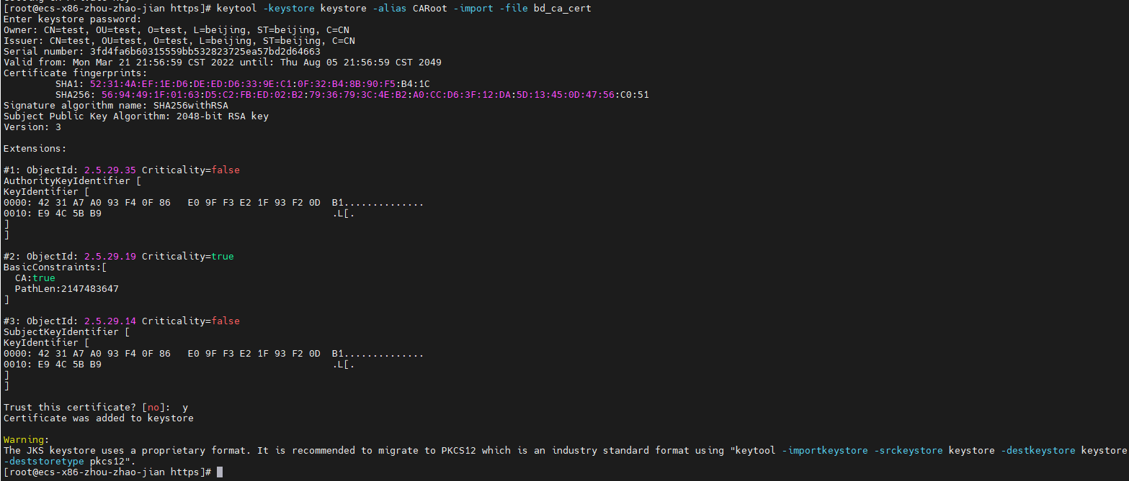

keytool -keystore keystore -alias localhost -import -file cert_signed

输入密码123456



# 7 整合配置hadoop ,hive、Kerberos

**步骤1** cd /bigdata/hadoop-2.6.0/etc/hadoop/

cp ssl-server.xml.example ssl-server.xml

vim ssl-server.xml

覆盖如下内容：

<?xml version="1.0"?>

<?xml-stylesheet type="text/xsl" href="configuration.xsl"?>

<!--

Licensed to the Apache Software Foundation (ASF) under one or more

contributor license agreements. See the NOTICE file distributed with

this work for additional information regarding copyright ownership.

The ASF licenses this file to You under the Apache License, Version 2.0

(the "License"); you may not use this file except in compliance with

the License. You may obtain a copy of the License at

http://www.apache.org/licenses/LICENSE-2.0

Unless required by applicable law or agreed to in writing, software

distributed under the License is distributed on an "AS IS" BASIS,

WITHOUT WARRANTIES OR CONDITIONS OF ANY KIND, either express or implied.

See the License for the specific language governing permissions and

limitations under the License.

-->

<configuration>

<property>

<name>ssl.server.truststore.location</name>

<value>/etc/hadoop/https/truststore</value>

<description>Truststore to be used by NN and DN. Must be specified.

</description>

</property>

<property>

<name>ssl.server.truststore.password</name>

<value>123456</value>

<description>Optional. Default value is "".

</description>

</property>

<property>

<name>ssl.server.truststore.type</name>

<value>jks</value>

<description>Optional. The keystore file format, default value is "jks".

</description>

</property>

<property>

<name>ssl.server.truststore.reload.interval</name>

<value>10000</value>

<description>Truststore reload check interval, in milliseconds.

Default value is 10000 (10 seconds).

</description>

</property>

<property>

<name>ssl.server.keystore.location</name>

<value>/etc/hadoop/https/keystore</value>

<description>Keystore to be used by NN and DN. Must be specified.

</description>

</property>

<property>

<name>ssl.server.keystore.password</name>

<value>123456</value>

<description>Must be specified.

</description>

</property>

<property>

<name>ssl.server.keystore.keypassword</name>

<value>123456</value>

<description>Must be specified.

</description>

</property>

<property>

<name>ssl.server.keystore.type</name>

<value>jks</value>

<description>Optional. The keystore file format, default value is "jks".

</description>

</property>

</configuration>

**步骤2 配置客户端**

cd /bigdata/hadoop-2.6.0/etc/hadoop/

cp ssl-client.xml.example ssl-client.xml

vim ssl-client.xml

覆盖

<?xml version="1.0"?>

<?xml-stylesheet type="text/xsl" href="configuration.xsl"?>

<!--

Licensed to the Apache Software Foundation (ASF) under one or more

contributor license agreements. See the NOTICE file distributed with

this work for additional information regarding copyright ownership.

The ASF licenses this file to You under the Apache License, Version 2.0

(the "License"); you may not use this file except in compliance with

the License. You may obtain a copy of the License at

http://www.apache.org/licenses/LICENSE-2.0

Unless required by applicable law or agreed to in writing, software

distributed under the License is distributed on an "AS IS" BASIS,

WITHOUT WARRANTIES OR CONDITIONS OF ANY KIND, either express or implied.

See the License for the specific language governing permissions and

limitations under the License.

-->

<configuration>

<property>

<name>ssl.client.truststore.location</name>

<value>/etc/hadoop/https/truststore</value>

<description>Truststore to be used by clients like distcp. Must be

specified.

</description>

</property>

<property>

<name>ssl.client.truststore.password</name>

<value>123456</value>

<description>Optional. Default value is "".

</description>

</property>

<property>

<name>ssl.client.truststore.type</name>

<value>jks</value>

<description>Optional. The keystore file format, default value is "jks".

</description>

</property>

<property>

<name>ssl.client.truststore.reload.interval</name>

<value>10000</value>

<description>Truststore reload check interval, in milliseconds.

Default value is 10000 (10 seconds).

</description>

</property>

<property>

<name>ssl.client.keystore.location</name>

<value>/etc/hadoop/https/keystore</value>

<description>Keystore to be used by clients like distcp. Must be

specified.

</description>

</property>

<property>

<name>ssl.client.keystore.password</name>

<value>123456</value>

<description>Optional. Default value is "".

</description>

</property>

<property>

<name>ssl.client.keystore.keypassword</name>

<value>123456</value>

<description>Optional. Default value is "".

</description>

</property>

<property>

<name>ssl.client.keystore.type</name>

<value>jks</value>

<description>Optional. The keystore file format, default value is "jks".

</description>

</property>

</configuration>

修改权限

chmod -R 755 /etc/hadoop/https/

cd /bigdata/

chown -R hive:hadoop apache-hive-1.1.0-bin

rm -rf hadoop-2.6.0/logs

mkdir -p hadoop-2.6.0/logs

chmod -R 777 hadoop-2.6.0

修改hadoop配置文件

**步骤3** cd hadoop-2.6.0/etc/hadoop/

vim core-site.xml

覆盖为如下内容

<?xml version="1.0" encoding="UTF-8"?>

<?xml-stylesheet type="text/xsl" href="configuration.xsl"?>

<!--

Licensed under the Apache License, Version 2.0 (the "License");

you may not use this file except in compliance with the License.

You may obtain a copy of the License at

http://www.apache.org/licenses/LICENSE-2.0

Unless required by applicable law or agreed to in writing, software

distributed under the License is distributed on an "AS IS" BASIS,

WITHOUT WARRANTIES OR CONDITIONS OF ANY KIND, either express or implied.

See the License for the specific language governing permissions and

limitations under the License. See accompanying LICENSE file.

-->

<!-- Put site-specific property overrides in this file. -->

<configuration>

<property>

<name>hadoop.tmp.dir</name>

<value>file:/usr/local/hadoop/tmp</value>

<description>Abase for other temporary directories.</description>

</property>

<property>

<name>fs.defaultFS</name>

<value>hdfs://localhost:9000</value>

</property>

<property>

<name>hadoop.proxyuser.hive.hosts</name>

<value>*</value>

</property>

<property>

<name>hadoop.proxyuser.hive.groups</name>

<value>*</value>

</property>

<property>

<name>hadoop.proxyuser.hdfs.hosts</name>

<value>*</value>

</property>

<property>

<name>hadoop.proxyuser.hdfs.groups</name>

<value>*</value>

</property>

<property>

<name>hadoop.proxyuser.HTTP.hosts</name>

<value>*</value>

</property>

<property>

<name>hadoop.proxyuser.HTTP.groups</name>

<value>*</value>

</property>

<property>

<name>hadoop.proxyuser.yarn.hosts</name>

<value>*</value>

</property>

<property>

<name>hadoop.proxyuser.yarn.groups</name>

<value>*</value>

</property>

<property>

<name>hadoop.security.authorization</name>

<value>true</value>

</property>

<property>

<name>hadoop.security.authentication</name>

<value>kerberos</value>

</property>

<property>

<name>hadoop.proxyuser.yarn.hosts</name>

<value>*</value>

</property>

<property>

<name>hadoop.proxyuser.yarn.groups</name>

<value>*</value>

</property>

</configuration>

**步骤4** 修改 hdfs-site.xml

vim hdfs-site.xml

覆盖为如下内容：

<?xml version="1.0" encoding="UTF-8"?>

<?xml-stylesheet type="text/xsl" href="configuration.xsl"?>

<!--

Licensed under the Apache License, Version 2.0 (the "License");

you may not use this file except in compliance with the License.

You may obtain a copy of the License at

http://www.apache.org/licenses/LICENSE-2.0

Unless required by applicable law or agreed to in writing, software

distributed under the License is distributed on an "AS IS" BASIS,

WITHOUT WARRANTIES OR CONDITIONS OF ANY KIND, either express or implied.

See the License for the specific language governing permissions and

limitations under the License. See accompanying LICENSE file.

-->

<!-- Put site-specific property overrides in this file. -->

<configuration>

<property>

<name>dfs.replication</name>

<value>1</value>

</property>

<property>

<name>dfs.namenode.name.dir</name>

<value>file:/usr/local/hadoop/tmp/dfs/name</value>

</property>

<property>

<name>dfs.datanode.data.dir</name>

<value>file:/usr/local/hadoop/tmp/dfs/data</value>

</property>

<!-- General HDFS security config -->

<property>

<name>dfs.block.access.token.enable</name>

<value>true</value>

</property>

<!-- NameNode security config -->

<property>

<name>dfs.namenode.keytab.file</name>

<value>/etc/hadoop/conf/hdfs.keytab</value>

</property>

<property>

<name>dfs.namenode.kerberos.principal</name>

<value>hdfs/localhost@EXAMPLE.COM</value>

</property>

<property>

<name>dfs.namenode.kerberos.internal.spnego.principal</name>

<value>HTTP/localhost@EXAMPLE.COM</value>

</property>

<!-- Secondary NameNode security config -->

<property>

<name>dfs.secondary.namenode.keytab.file</name>

<value>/etc/hadoop/conf/hdfs.keytab</value>

</property>

<property>

<name>dfs.secondary.namenode.kerberos.principal</name>

<value>hdfs/localhost@EXAMPLE.COM</value>

</property>

<property>

<name>dfs.secondary.namenode.kerberos.internal.spnego.principal</name>

<value>HTTP/localhost@EXAMPLE.COM</value>

</property>

<!-- DataNode security config -->

<property>

<name>dfs.datanode.data.dir.perm</name>

<value>700</value>

</property>

<!--<property>

<name>dfs.datanode.address</name>

<value>0.0.0.0:50010</value>

</property>

<property>

<name>dfs.datanode.http.address</name>

<value>0.0.0.0:50075</value>

</property>-->

<property>

<name>dfs.datanode.keytab.file</name>

<value>/etc/hadoop/conf/hdfs.keytab</value>

</property>

<property>

<name>dfs.datanode.kerberos.principal</name>

<value>hdfs/localhost@EXAMPLE.COM</value>

</property>

<!-- Web Authentication config -->

<property>

<name>dfs.web.authentication.kerberos.principal</name>

<value>HTTP/localhost@EXAMPLE.COM</value>

</property>

<property>

<name>dfs.journalnode.keytab.file</name>

<value>/etc/hadoop/conf/hdfs.keytab</value>

</property>

<property>

<name>dfs.journalnode.kerberos.principal</name>

<value>hdfs/localhost@EXAMPLE.COM</value>

</property>

<property>

<name>dfs.journalnode.kerberos.internal.spnego.principal</name>

<value>HTTP/localhost@EXAMPLE.COM</value>

</property>

<property>

<name>dfs.data.transfer.protection</name>

<value>integrity</value>

</property>

<property>

　　　　<name>dfs.http.policy</name>

　　　　<value>HTTPS_ONLY</value>

</property>

</configuration>

**步骤5** 修改 yarn-site.xml

vim yarn-site.xml

完全覆盖

<?xml version="1.0"?>

<!--

Licensed under the Apache License, Version 2.0 (the "License");

you may not use this file except in compliance with the License.

You may obtain a copy of the License at

http://www.apache.org/licenses/LICENSE-2.0

Unless required by applicable law or agreed to in writing, software

distributed under the License is distributed on an "AS IS" BASIS,

WITHOUT WARRANTIES OR CONDITIONS OF ANY KIND, either express or implied.

See the License for the specific language governing permissions and

limitations under the License. See accompanying LICENSE file.

-->

<configuration>

<!-- Site specific YARN configuration properties -->

<property>

<name>yarn.nodemanager.aux-services</name>

<value>mapreduce_shuffle</value>

</property>

<!-- ResourceManager security configs -->

<property>

<name>yarn.resourcemanager.keytab</name>

<value>/etc/hadoop/conf/yarn.keytab</value>

</property>

<property>

<name>yarn.resourcemanager.principal</name>

<value>yarn/localhost@EXAMPLE.COM</value>

</property>

<!-- NodeManager security configs -->

<property>

<name>yarn.nodemanager.keytab</name>

<value>/etc/hadoop/conf/yarn.keytab</value>

</property>

<property>

<name>yarn.nodemanager.principal</name>

<value>yarn/localhost@EXAMPLE.COM</value>

</property>

<property>

<name>yarn.resourcemanager.proxy-user-privileges.enabled</name>

<value>true</value>

</property>

</configuration>

**步骤6** 修改 mapred-site.xml

vim mapred-site.xml

完全覆盖

<?xml version="1.0"?>

<?xml-stylesheet type="text/xsl" href="configuration.xsl"?>

<!--

Licensed under the Apache License, Version 2.0 (the "License");

you may not use this file except in compliance with the License.

You may obtain a copy of the License at

http://www.apache.org/licenses/LICENSE-2.0

Unless required by applicable law or agreed to in writing, software

distributed under the License is distributed on an "AS IS" BASIS,

WITHOUT WARRANTIES OR CONDITIONS OF ANY KIND, either express or implied.

See the License for the specific language governing permissions and

limitations under the License. See accompanying LICENSE file.

-->

<!-- Put site-specific property overrides in this file. -->

<configuration>

<property>

<name>mapreduce.framework.name</name>

<value>yarn</value>

</property>

<property>

<name>mapreduce.jobhistory.keytab</name>

<value>/etc/hadoop/conf/mapred.keytab</value>

</property>

<property>

<name>mapreduce.jobhistory.principal</name>

<value>mapred/localhost@EXAMPLE.COM</value>

</property>

<property>

<name>mapreduce.jobhistory.webapp.spnego-principal</name>

<value>HTTP/localhost@EXAMPLE.COM</value>

</property>

<property>

<name>mapreduce.jobhistory.webapp.spnego-keytab-file</name>

<value>/etc/hadoop/conf/mapred.keytab</value>

</property>

</configuration>

**步骤7**修改/bigdata/apache-hive-1.1.0-bin/conf/hive-site.xml

vim /bigdata/apache-hive-1.1.0-bin/conf/hive-site.xml

完全覆盖

<configuration>

<property>

<name>javax.jdo.option.ConnectionURL</name>

<value>jdbc:mysql://localhost:3306/hive?createDatabaseIfNotExist=true&amp;useSSL=false</value>

</property>

<property>

<name>javax.jdo.option.ConnectionDriverName</name>

<value>com.mysql.jdbc.Driver</value>

</property>

<property>

<name>javax.jdo.option.ConnectionUserName</name>

<value>root</value>

</property>

<property>

<name>javax.jdo.option.ConnectionPassword</name>

<value>123456</value>

</property>

<property>

<name>hive.server2.thrift.bind.host</name>

<value>localhost</value>

</property>

<property>

<name>hive.server2.thrift.port</name>

<value>10000</value>

</property>

<property>

<name>hive.sentry.conf.url</name>

<value>file:///bigdata/apache-hive-1.1.0-bin/conf/sentry-site.xml</value>

</property>

<property>

<name>hive.stats.collect.scancols</name>

<value>true</value>

</property>

<property>

<name>hive.metastore.pre.event.listeners</name>

<value>org.apache.sentry.binding.metastore.MetastoreAuthzBinding</value>

</property>

<property>

<name>hive.metastore.event.listeners</name>

<value>org.apache.sentry.binding.metastore.SentryMetastorePostEventListener</value>

</property>

<property>

<name>hive.server2.session.hook</name>

<value>org.apache.sentry.binding.hive.HiveAuthzBindingSessionHook</value>

</property>

<property>

<name>hive.security.authorization.task.factory</name>

<value>org.apache.sentry.binding.hive.SentryHiveAuthorizationTaskFactoryImpl</value>

</property>

<property>

<name>hive.server2.authentication</name>

<value>KERBEROS</value>

</property>

<property>

<name>hive.server2.authentication.kerberos.principal</name>

<value>hive/localhost@EXAMPLE.COM</value>

</property>

<property>

<name>hive.server2.authentication.kerberos.keytab</name>

<value>/etc/hive/conf/hive.keytab</value>

</property>

<property>

<name>hive.metastore.sasl.enabled</name>

<value>true</value>

</property>

<property>

<name>hive.metastore.kerberos.keytab.file</name>

<value>/etc/hive/conf/hive.keytab</value>

</property>

<property>

<name>hive.metastore.kerberos.principal</name>

<value>hive/localhost@EXAMPLE.COM</value>

</property>

</configuration>

**步骤8 修改权限**

chmod -R 777 /usr/local/Hadoop

chmod -R 777 /bigdata/logs

chown -R hdfs:hadoop /usr/local/hadoop/tmp/dfs/data/

**步骤9**启动Hadoop各个组件

启动hdfs

su – hdfs

获取Kerberos票据

kinit -kt /etc/hadoop/conf/hdfs.keytab hdfs/localhost@EXAMPLE.COM

klist查看

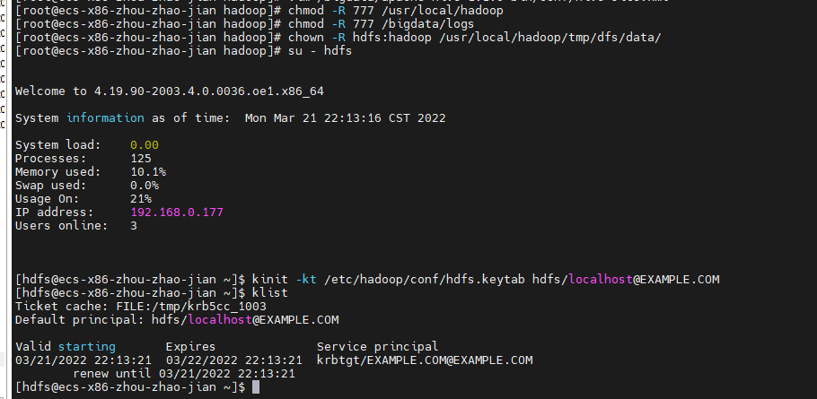

启动namenode

hadoop-daemon.sh start namenode

启动成功

启动datanode

hadoop-daemon.sh start datanode



vim /bigdata/hadoop-2.6.0/logs/hadoop-hdfs-datanode-ecs-arm-zhou-zhao-jian-sentry-2.log

查看datanode

启动成功

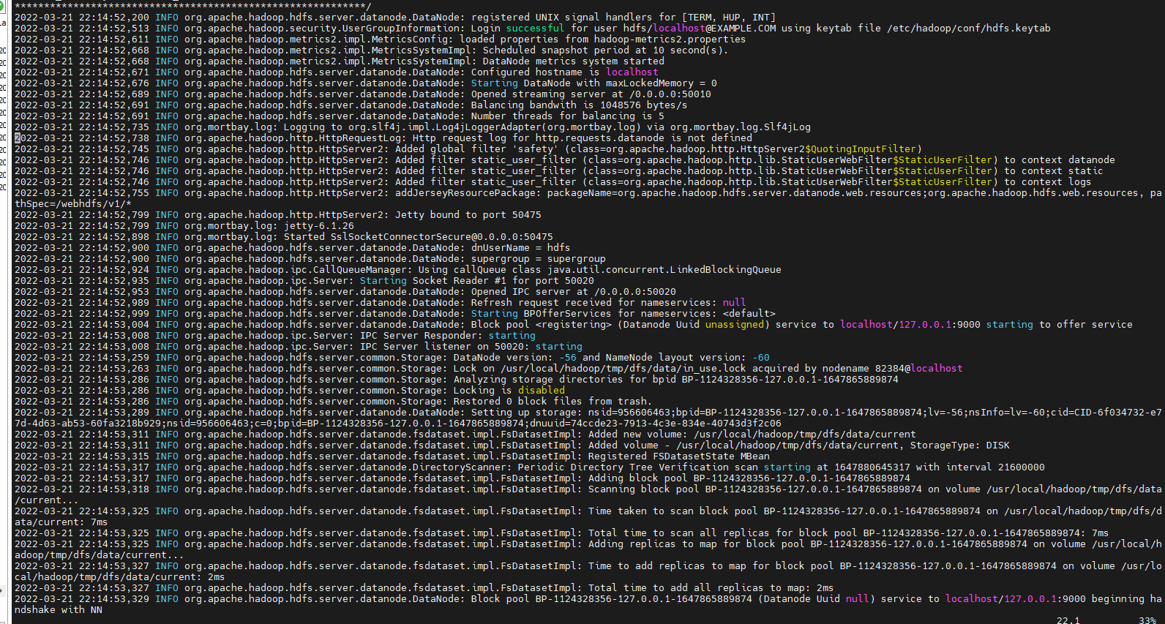

退出

exit;

启动jobhistory

su – mapred

获取票据

kinit -kt /etc/hadoop/conf/mapred.keytab mapred/localhost@EXAMPLE.COM

查看 klist

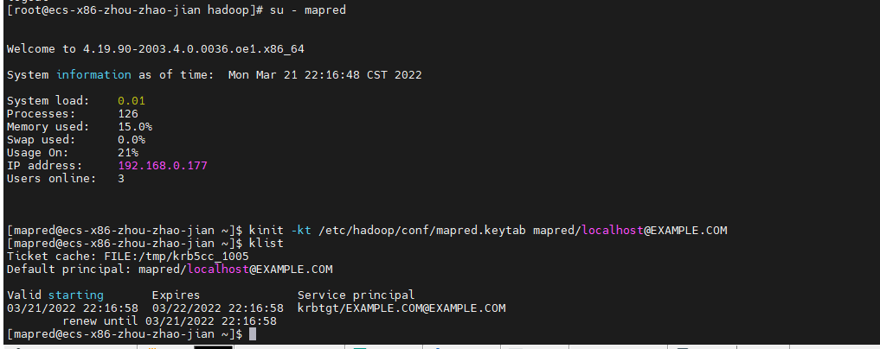

启动

mr-jobhistory-daemon.sh start historyserver

vim vim /bigdata/hadoop-2.6.0/logs/mapred-mapred-historyserver-ecs-x86-zhou-zhao-jian.log

查看mapred

启动成功

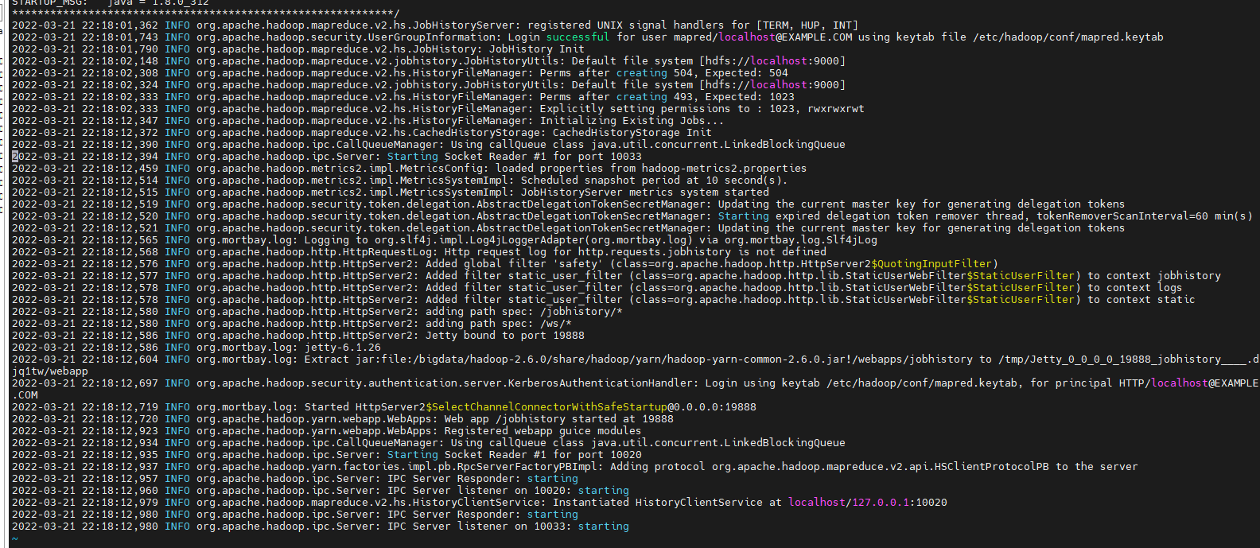

退出

exit;

启动yarn resourcemanager nodemanager

su – yarn

kinit -kt /etc/hadoop/conf/yarn.keytab yarn/localhost@EXAMPLE.COM

klist

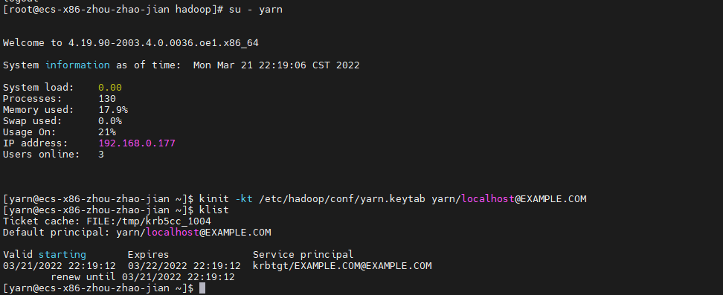

yarn-daemon.sh start resourcemanager

#查看启动日志，是否有报错

vim /bigdata/hadoop-2.6.0/logs/yarn-yarn-resourcemanager-ecs-x86-zhou-zhao-jian.log

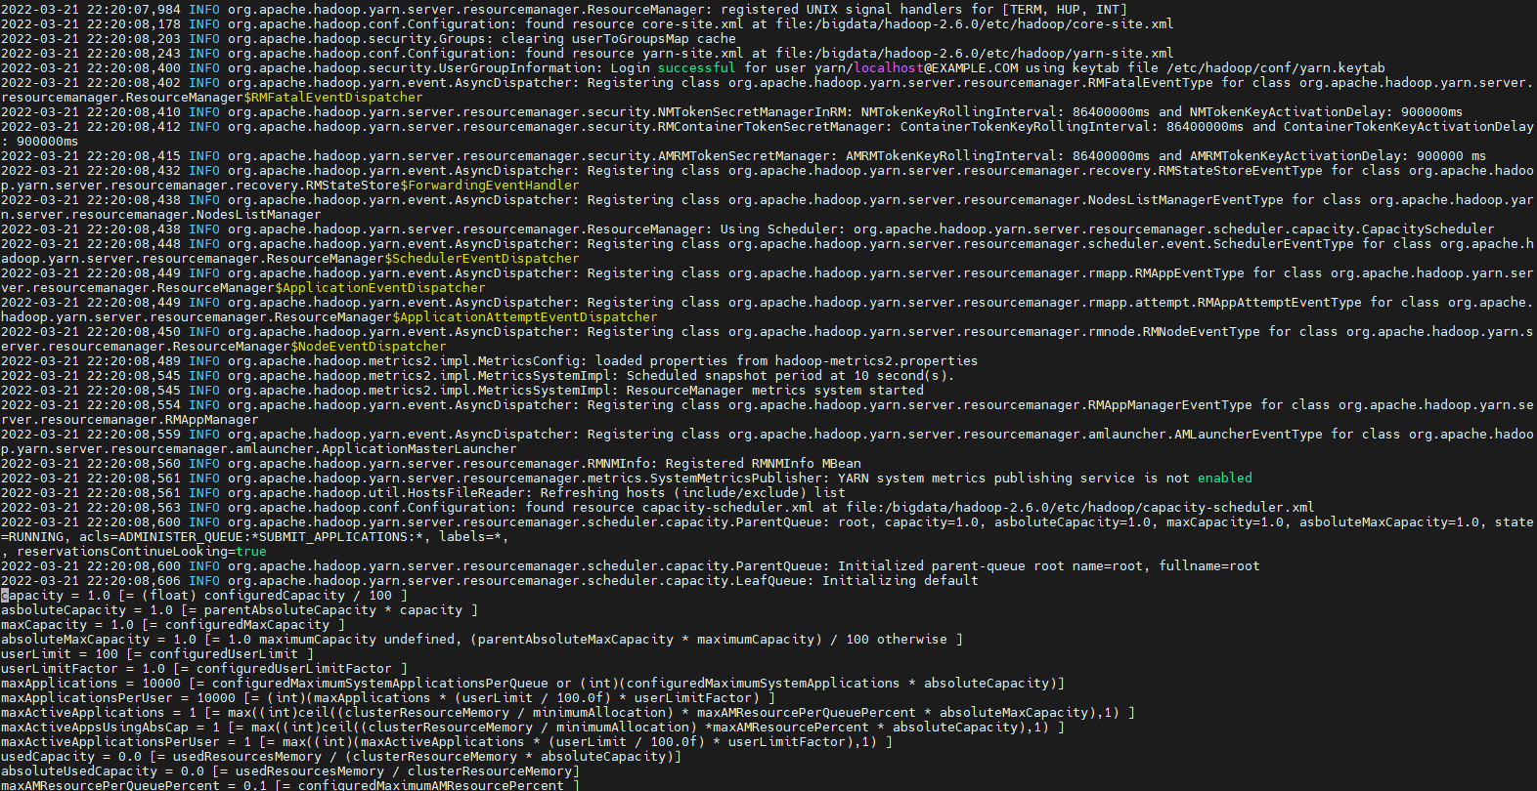

nodemanager

yarn-daemon.sh start nodemanager

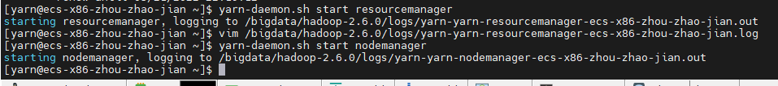

查看启动情况

vim /bigdata/hadoop-2.6.0/logs/yarn-yarn-nodemanager-ecs-x86-zhou-zhao-jian.log

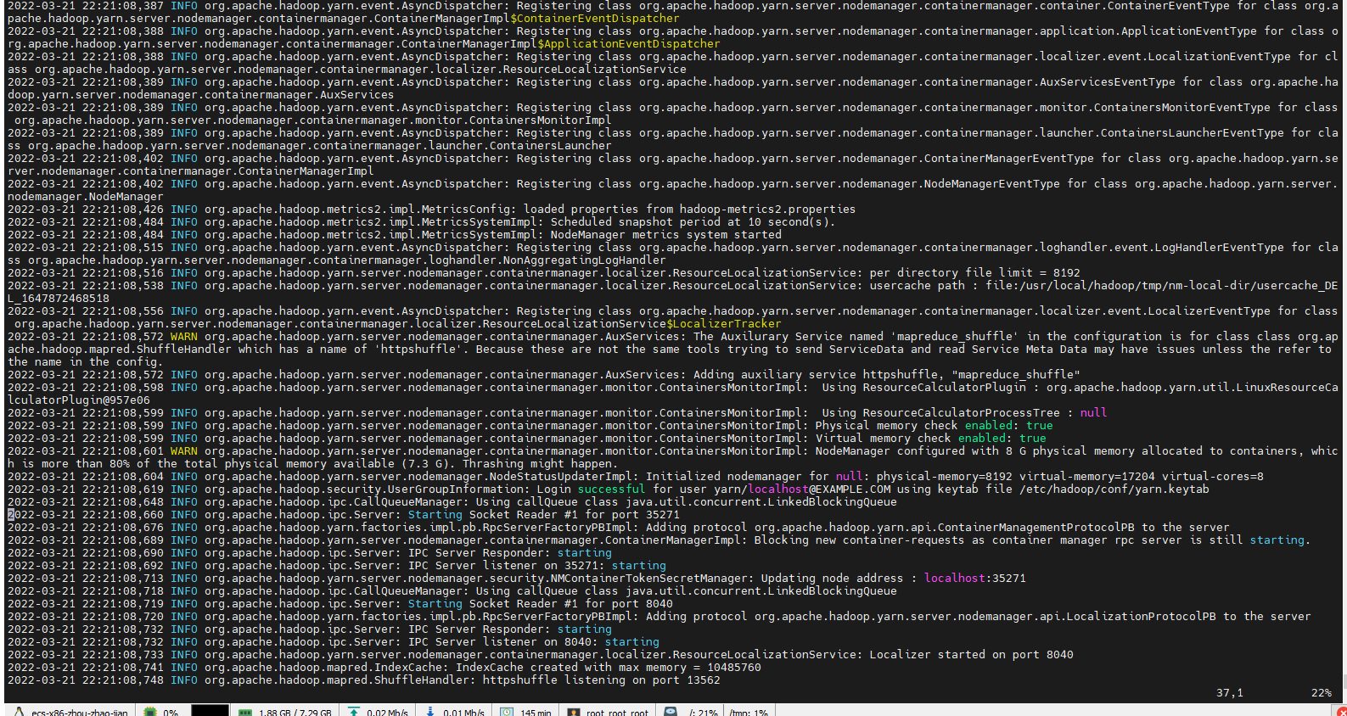

exit;

启动hive

su - hive

kinit -kt /etc/hive/conf/hive.keytab hive/localhost@EXAMPLE.COM

klist

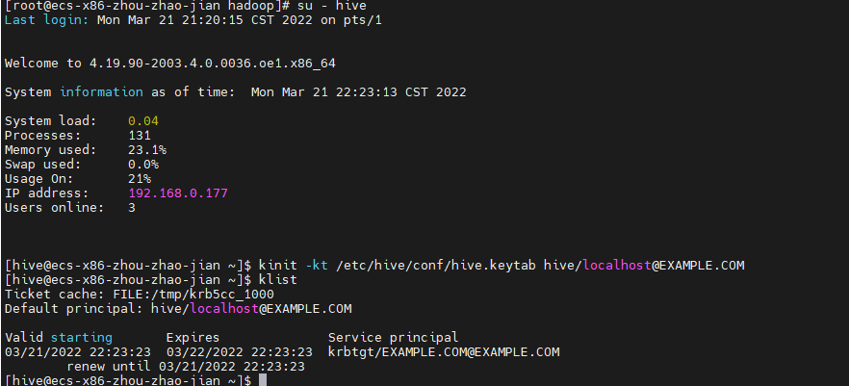

后台启动hive

nohup hive --service metastore >> /bigdata/logs/hive-metastore.log 2>&1 &

nohup hive --service hiveserver2 >> /bigdata/logs/hive-server2.log 2>&1 &

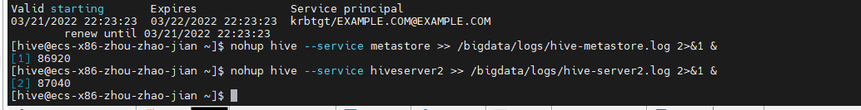

查看

hive

show databases;

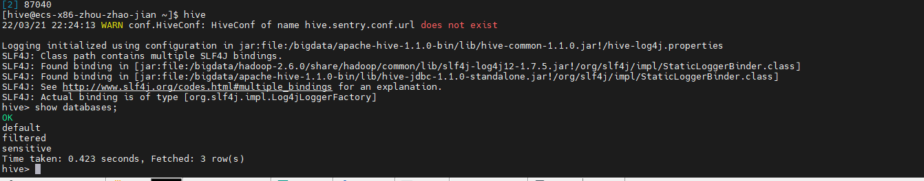

退出

exit;

# 8 Kerberos，sentry整合完毕，验证权限

**步骤1 hive 用户权限验证**

hive用户在sentry上前面是没有任何授权的，理论是没有权限

使用hive账户登录

su – hive

使用beeline连接

beeline -u "jdbc:hive2://localhost:10000/;principal=hive/localhost@EXAMPLE.COM" -n hive -p hive

因为sentry权限控制保护，hive用户不能查看roles 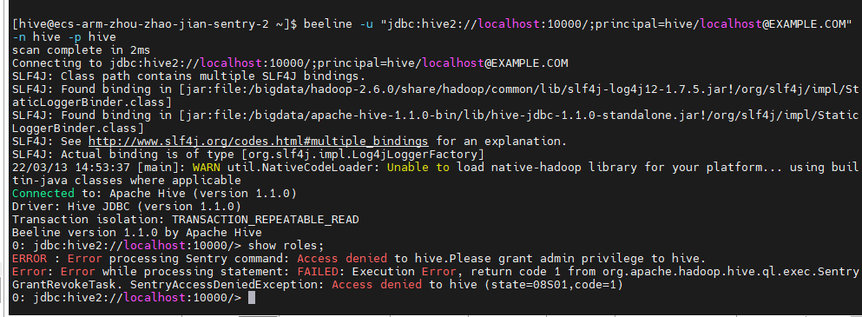

sentry生效

可以查看hive数据库

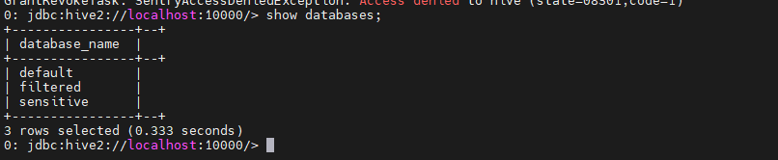

sentry没有给hive用户select权限

select ip from sensitive.events;

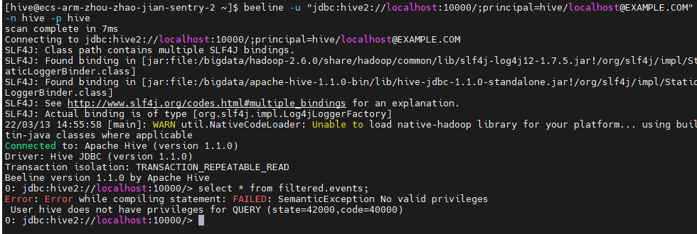

退出hive2 :!quit

退出hive 用户 logout

**步骤2 admin 用户权限验证，**

登录admin 用户

cd

su – admin

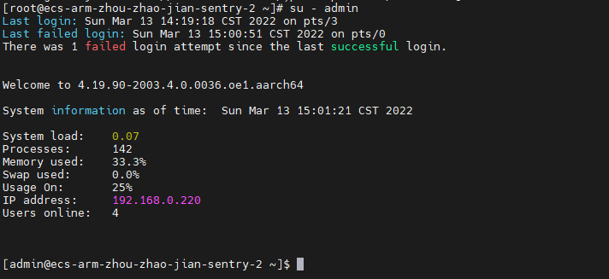

拿到admin用户kerberos票据，验证Kerberos权限，登录

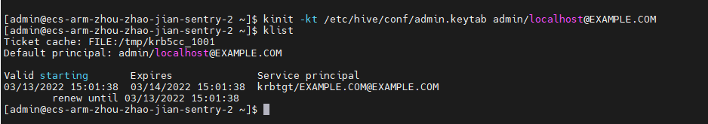

连接hive

beeline -u "jdbc:hive2://localhost:10000/;principal=hive/localhost@EXAMPLE.COM" -n hive -p hive

连接成功，并显示角色

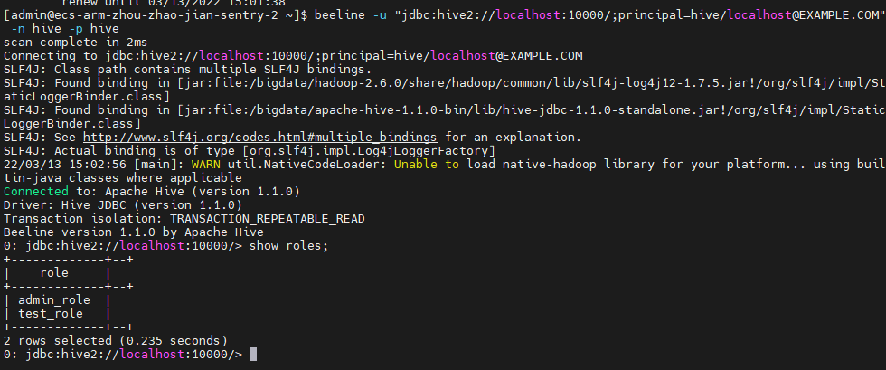

查看admin角色权限

show grant role admin_role;

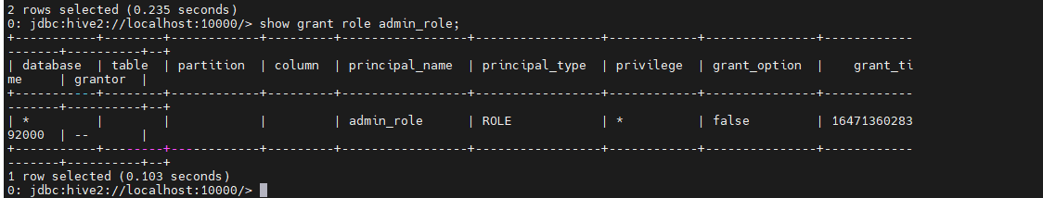

查看test用户的权限

show grant role test_role;

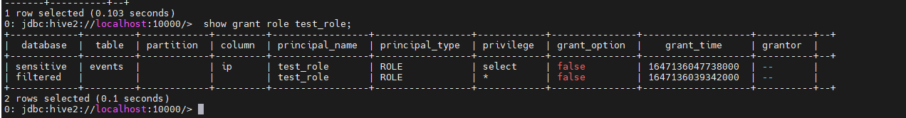

查看数据库并进行查询操作

show databases;

select * from filtered.events;

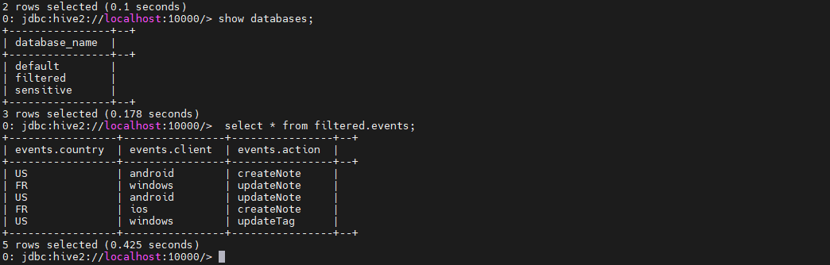

select * from sensitive.events;

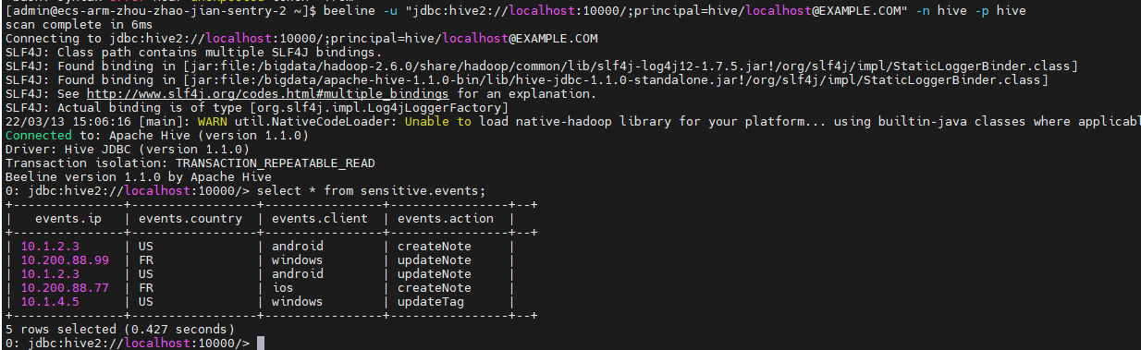

admin用户权限验证完成

退出，!quit,并 logout

**步骤3 test用户权限验证**

cd

su – test

拿到test用户kerberos票据，验证Kerberos权限，登录

kinit -kt /etc/hive/conf/test.keytab [test/localhost@EXAMPLE.COM](mailto:test/localhost@EXAMPLE.COM)

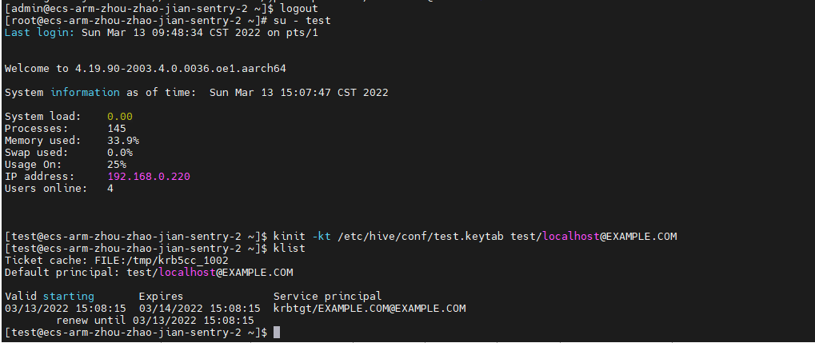

beeline连接

beeline -u "jdbc:hive2://localhost:10000/;principal=hive/localhost@EXAMPLE.COM" -n hive -p hive

test用户不是管理员，是不能查看所有角色的

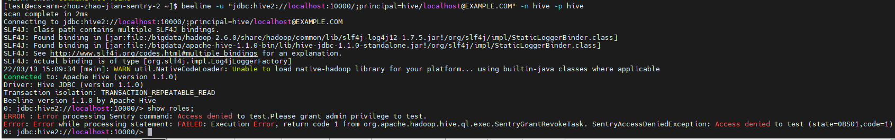

test用户能查看数据库，能查filtered数据库，只能查sensitive库里面events表的ip字段，其余不能查询。

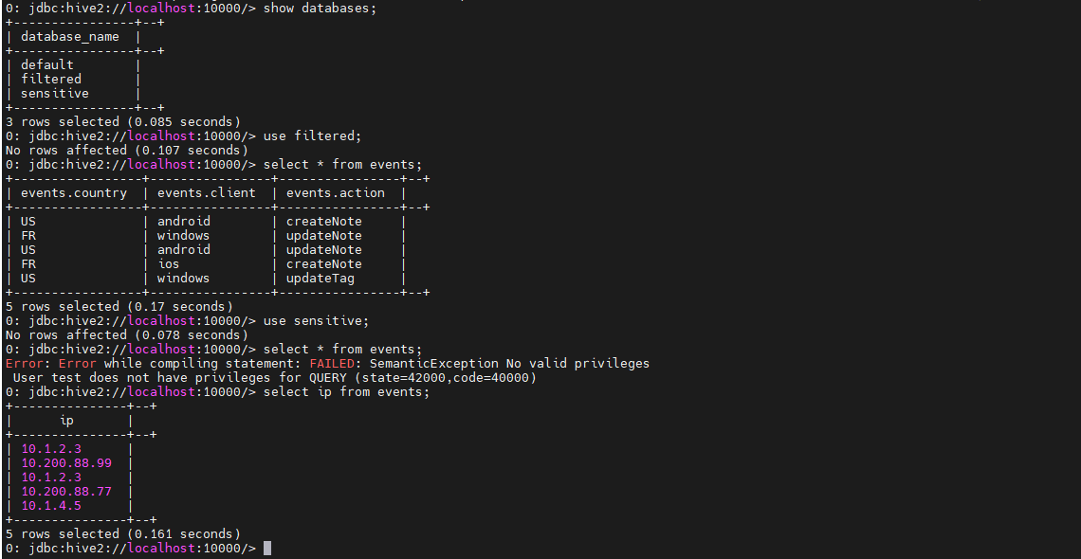

**步骤4 没有票据用户验证**

添加用户

useradd kb5test

切换用户

su - kb5test

beeline连接：

beeline -u "jdbc:hive2://localhost:10000/;principal=hive/localhost@EXAMPLE.COM" -n hive -p hive

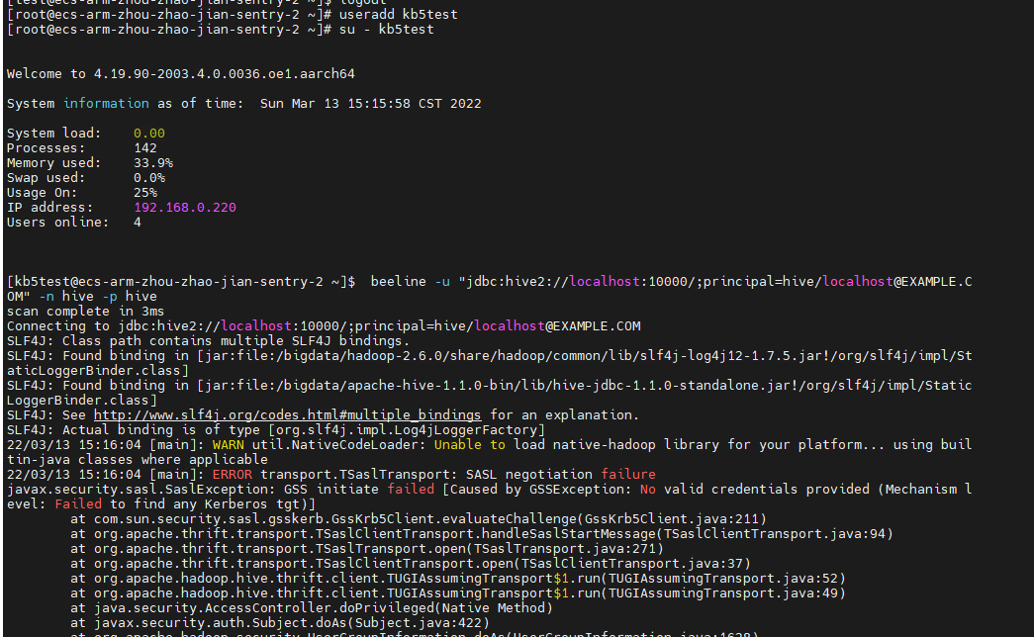

未通过Kerberos验证

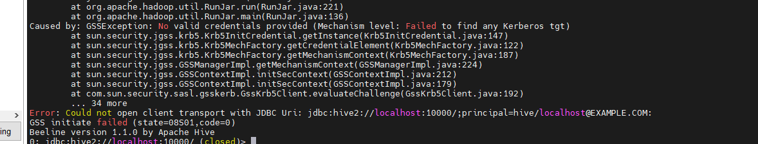

**步骤6 创建新用户并获取Kerberos票据验证**

创建新用户，

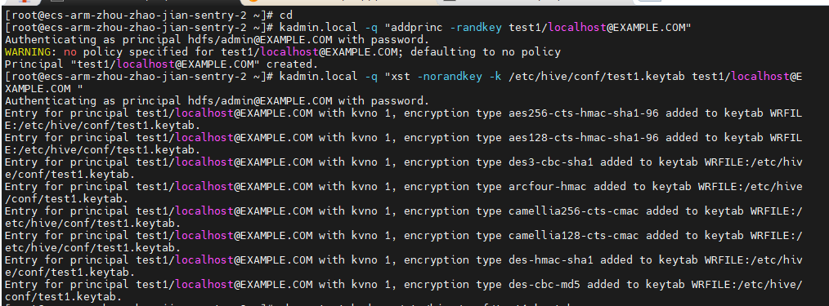

生成票据，并获取

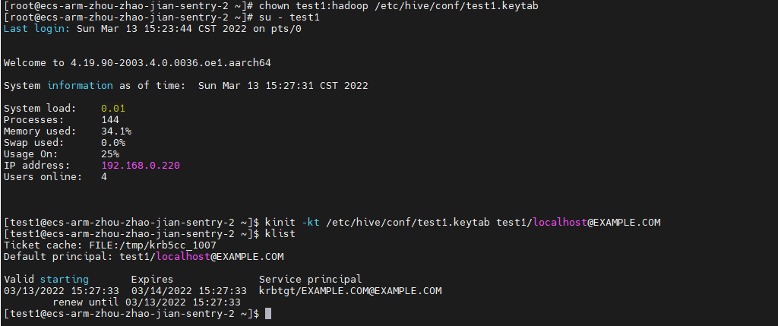

beeline 连接

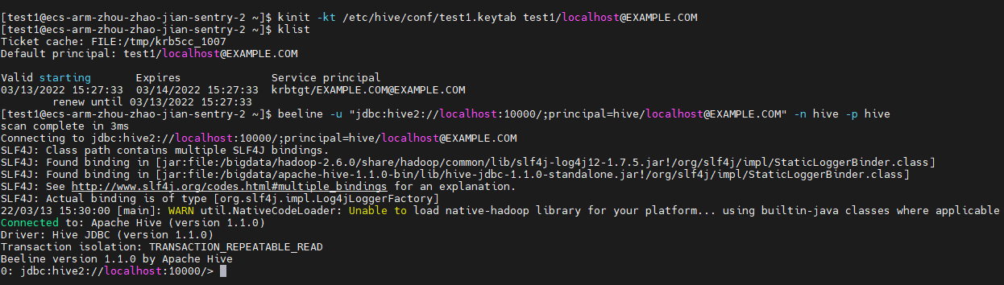

成功连接，但是未授权，

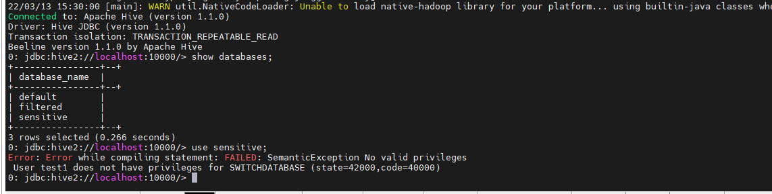

验证完毕！

rpm安装

